**Building a Logistic Website for a Small Mail & Cargo Business**

**Supervisor: Dr Mohammed Hassouna**

**COMP1682 Project (CIS)**

**A dissertation submitted in partial fulfilment of the University of Greenwich’s**

**BSc (Hons) BUSINESS COMPUTING**

**Due Date: 18th April 2016**

**Product and Development files: Uploaded as zip file**

Word count: **12141**

**ABSTRACT**

This project aim is to use the evolving technology to develop an interactive website the “MailSmart” business to attract more customers. The report will evaluate extensively all the relevant research procedures undertaken and use solutions obtained from the research conducted to aid during the development and planning process of this project to solve problems. Furthermore the report will discuss the industry accredited methodologies and techniques used within the planning and development process throughout the lifecycle of the project.

**ACKNOWLEDGEMENTS**

This project would not have been possible to accomplish without the help and guidance of numerous important people who have been very encouraging throughout this project. Special acknowledgements for these who made this project a realization.

Special Thanks and gratitude to Dr Mohammed Hassouna, who has been the personal supervisor of this project, for his excess of support and guidance throughout the project offering helpful assistance, vital feedback and inspiration that helped to shape the final deliverable to achieve the targeted functionalities in due course.

Mr Tony Valsamidis, the Second supervisor for his valuable feedback and comments and knowledge sharing that aided the project documentation process.

**Table of Contents**

1 Introduction 3

1.1 Background 4

1.2 Aims 4

1.3 Objectives 4

2 Development Methodology 5

2.1 Requirement Analysis 5

2.2 Requirement List 5

2.3 Prioritised Requirements List 6

2.4 Functional requirements 7

2.5 Non-Functional requirements 7

Usability 7

2.6 Accessibility 7

2.7 Data Backup 7

2.8 Performance 7

3 Chapter 3: Literature Review 8

3.1 Introduction 8

3.2 Identifying the problem 8

3.3 Problem with HCI/Human Error 9

3.4 Human interface guidelines 11

3.5 Design features 12

3.6 Accessibility 12

3.7 Guidelines for universal design 13

3.8 Rules and principles of HCI 14

3.9 Conclusion 16

4 Evaluation of Existing Product 18

4.1 Parcel 2 go 18

4.2 Interparcel 19

4.3 Parcel monkey 21

4.4 Comparison Table 23

4.5 Conclusions 24

5 Legal, Ethical and Social and Professional Issues 25

6 Designing of “MailSmart” website 26

6.1 Database design 26

6.2 Structural Overview 26

6.3 Site Layout and Design 26

6.4 Home Page design sketch 27

6.5 Coverage Page design sketch 28

6.6 Business to Business Page design sketch 28

6.7 About Us Page design sketch 29

6.8 Contact Us Page design sketch 30

6.9 Login and Registration Page design sketch 31

6.10 User Account and Admin Page design sketch 31

6.11 Colour Scheme 33

7 Development Process 33

7.1.1 Use case 34

7.1.2 Class Diagram 35

7.1.3 Database 35

7.1.4 Time Box 36

7.1.5 Development Tools 38

7.2 Implementation of functionalities 38

7.2.1 Home Page 38

7.2.2 Register (CSS code) 40

7.2.3 User _Account View 42

7.2.4 Contact Us Page 43

7.2.5 Admin 43

8 Testing 44

9 Evaluation 45

9.1 Evaluation of Product 45

9.2 Future Development 46

9.2.1 Responsive design techniques 46

9.2.2 Enabling Payment Method 46

9.2.3 Tracking System 46

9.2.4 Mobile Application 46

9.3 Self-Evaluation 47

10 Conclusion 48

11 References 49

12 Appendices 51

12.1 Appendix A- Project Proposal 51

12.2 APPENDIX B- Work Schedule (Gantt chart) 54

12.3 APPENDIX C-Existing Product Comparison Table 55

12.4 APPENDIX D- Testing table 57

12.5 APPENDIX E- Testing 59

12.6 APPENDIX F- Record of Client Meetings 60

12.7 Appendix –G Coding segments explained 61

12.7.1 Home Page CSS Code 61

12.7.2 Registration Page CSS Code 63

12.7.3 Login Page CSS Code 64

12.7.4 Contact Us Page CSS Code 66

# 1 Introduction

The project will investigate the different factors needed to be taken into consideration when implementing technology solutions for use within the design of logistic website, to ensure that the applied solutions are successful and suitable for the environments to which they are applied. This investigation aims is to compile a list of requirements for technology solutions which will be used within web design for the “MailSmart” logistic site. The project will then apply these obtained techniques to a real life scenario which will start by doing the development of a prototype sketch for the system for the client of “MailSmart” website.

The developed system will then be tested against the list of requirements, with the aim of determining its suitability for use within the website.

This report will discuss the dominant methodology and planning techniques used within most project development process to make sure this project meets its innovation milestones in due course and deliver the final product while accomplishing a comprehensive approach to a professionally designed and developed invention.

The final deliverable of this project will be a functional prototype version of the new “MailSmart” website that would be focusing attracting potential customers for the “MailSmart” business through a personalisation which would be developed using techniques that allows future developments of the website.

## 1.1 Background

This literature review will examine the current problems related to this project. It will look at the changes which need to be taken into consideration when implementing innovative technology solution in designing logistic website, to ensure that applied solution are successful, engaging and suitable for the type of environment to which it applied and to meet users expectation . The examination aim is to bring together a list of requirements for the technology solutions which will be used within a logistic website situations.

The project will then apply the techniques to develop a prototype website for a start-up logistic website. The developed website will be tested against the list of requirements, with the aim of determining customer’s expectation and making it interactive for user within the logistic domain.

## 1.2 Aims

The aim of this project is create a website site with combined techniques and features from research and existing websites that contribute to the appropriateness and success of the small start-up business.

## 1.3 Objectives

There are many objectives that need to be completed for this project. These are:

* Literature Review
* Review of existing products
* Gathering of Primary Research and requirements
* Completing a development plan
* Implementation of product
* Testing
* Evaluation of product

# 2 Development Methodology

This project will be developed using Dynamic System Development Methodology (DSDM), ascending down to the simple criteria of the techniques in order to suit the issues such as time controls and the scope of the project.

This agile development method is the chosen methodology as it the most commonly used for project, that need to be delivered in time set or deadline. Agile methodology also uses the 8:20 rules which fit within the parameters of this project. This methodology follows the basic techniques of the Rapid application development model (RAD), which focused on providing the client with a functioning end product using cost and time effectively although it doesn’t compromise on quality. It also uses Time boxing to ensure that all requirements needed for the site to be up and running is allocated a fix time period. These important conceptual tools and techniques of the DSDM framework was exercised to ensure that it would keep the development on a structural format in order to deliver the product in a professional manner.

## 2.1 Requirement Analysis

An initial requirement analysis was conducted with the client of the business before the design and development of the proposed website, in order to have a better understanding the end user requirements for the site, this project relies heavily on the interaction and usability of the system. The requirement that effect the system were found during the research carried out with end users as well as the finding gained during the general research to assist in delivering the requirements needed to build the planned site.

The requirement analysis was used to determine the positive and negative side relating to the propose project, while taking into consideration the finding to provide an easy clarification to current issues relating to the existing project. These will be discussed in the literature review and the reviewing of the existing product in the report.

## 2.2 Requirement List

The following list contains the requirements gathered during the meeting with the client of the

“MailSmart” Business.

* Enabling customers to register on the website
* Enabling the customer to access personal profile of their own
* Customers to be able to request for quotation
* Customers be able to leave request for Collections
* Customers to be able to contact for any Issues
* Create an admin profile
* Link with social network
* Send email confirmation for all orders
* Customers to quote history
* Customers able to track

## 2.3 Prioritised Requirements List

After the initial requirement analysis, the listed requirements had to be classified accordingly focus more on the main requirement and eliminate any that could be used as feature development due to the time constraints of the project, this will done using the MoSCoW prioritisation technique.

The technique of MoSCoW prioritisation is used in Dynamic system method which help developers to carry out development tasks established during the high level requirement criteria that gets prioritised into “Must have, Should have, Could have” which will give the Must have requirements a high level of prioritisation which must be delivered, while the “Should have” requirement can be delivered depending on the available resources after the “Must have”. The

“Could have” requirement are considered to be implemented for a desire and could have a great but will not affect the overall site. The Moscow Prioritisations will ensure effectiveness is applied to the project, care will be taken to ensure that no more than 60% of the total effort will be allocated to must have requirements. The 80:20 rule will be applied to the Moscow prioritised requirements aiming for 80% of the functionality to be delivered in 20% of the time.

The table below is the list of the MoSCoW prioritisation technique used for the project requirement list

|  |  |  |
| --- | --- | --- |
|  | High Level requirement | Priority |
| • | Customers to be able to request for quotation | Must |
| • | Enabling customers to register on the website | Must |
| • | Send email confirmation for all orders | Must |
| • | Customers to be able to contact for any Issues | Must |
| • | Customers to be able to login | Must |
| • | Admin to view request for collection | Should |
| • | Create User Account | Should |
| • | Enabling the customer to amend details | Should |
| • | Customers to view quote history in user account |  |
| • | Create Admin page | Should |
| • | Enabling Admin to view All quote request in Admin account | Should |
| • | Enabling Admin to view All enquiries in in Admin account | Should |
| • | Link with social network | Could |
| • | Customers able to track | Could |

## 2.4 Functional requirements

Below is the functional requirements that the site expected to delivery to the end user

Registered Customer

* Enabling customers to register on the website
* Enabling the customer to access personal profile of their own
* Customers to be able to request for quotation
* Customers be able to leave request for Collections
* Customers to be able to contact for any Issues
* Create an admin profile

Potential Customer

• Able to register on the website.

## 2.5 Non-Functional requirements

These requirements can play a major role on the website hence after the initial research phase and the comparison of the existing product it was possible to identify important areas of the site requirement.

## Usability

During the development of any system usability requirement is the most significant nonfunctional requirement that been recognised. For this project the structure of the navigation bar of the site has been design with guidelines of Nielson found in the research. As the project website is mostly user focussed, the usability requirement mentioned in the development was assigned as very important when it’s was carried out.

## 2.6 Accessibility

This is one of the most essential non-functional requirement that users of the site could be victim of visual disabilities that might limit the accessibility to site. The concern was address in the designing of the site by choosing the suitable colour, navigation bar and font to help tackle these issues.

## 2.7 Data Backup

The system is develop to hold a vast amount of data using database tools using SQL Server management studio which will work as hard drive that will hold all information share on the site. It is vital to create a data backup to help restore if a crash happen. All the data backed could be held in a server which update constantly all data automatically and also help improve the security and reliability of data shared on the site.

## 2.8 Performance

The site performance is very important and any delay involve in the site performance must be fewer. So in every action performed on the site, the respond time should be without no delays. There should be no delay when opening a window forms on the site and there should be an error message that will appears any fault occur.

# 3 Chapter 3: Literature Review

## 3.1 Introduction

This research will focus on identifying latest technologies involve in the Human Computer Interaction within the chosen field of this project. The main purpose of this research is to find problems related to technology used to the project.

## 3.2 Identifying the problem

Human Computer Interaction (HCI) is study focused on how human interact with computers and to what extend whether computers are develop for a successful interaction with people. A number of major academic institutions and corporations are studying HCI as the real fact is that different users from a range of conception or mental models have different technique of learning and keeping knowledge and skills. One important fact to consider about HCI technology is the rapid changes that is offering the new interaction possibilities to a level which previous research finding may. As the technology is evolving human preference changes as the gradually master new interface. (Rouse, 2005)

Human Computer Interaction (HCI) consist of three parts: the user the computer and the interaction between the both.

The user is the first part that will be discus, as human trying to get job done using the technology people hold different knowledge of using computers. An appreciation of the way human sensor system(sight, hearing, touch) relay information is very important to designing a product that suit everyone. (Danino, Sitepoint, 2001)

The second part is the computer this refer to many range of technologies from desktop computer, to huge scale of computer systems. This discus on how the functionality on websites work as many have different design.

The third part is the interaction between both the user and the computer, although there is a huge difference between human and machines. HCI objective is to make sure that each get the other successfully. To guarantee this achievement website usability need to be done to a high level and ensuring that the designer apply what human know about computers, and consulter users throughout the design process.

HCI goal is ensure that it produce usable and safe system, as well as functional system. In order to produce computer system with good usability, the developer must take in consideration to understand the factors that determine how human use technology, ensure that it develop tools and techniques to enable building suitable system. For this to then get efficiently, effectiveness and safe interaction to be achieve. Underlying the whole theme of HCI is the belief that that human who will be using the computer should be place first. The system should be design to meet people needs, capabilities and preference for conducting various tasks, people should not change how the use computer in order to suit the system. Instead it should be design to their requirement. The same goal can be applied to website to make usable, functional and safe to enable users to perform variety of tasks without any problem. (Danino, Sitepoint, 2001)

## 3.3 Problem with HCI/Human Error

The major problem with HCI design is taken corrective action, the system are not like human, if an error occur a human operation is needed to handle an emergency. Although human cannot perform repetitive task as computer but are much better at handling unusual incidents. Another problem is the stress level arising this can be avoided by providing training to the user so that it can be considered as familiar or usual situation. (Shelton, n.d.)

####  User experience

It is very important to raise the user experience awareness on website as it is a broader field of Human computer interaction. In the last few years, UX has arose as an umbrella term to describe the usability and quality of use of interactive system. Researchers and experts have started using UX as a foundation concept instead of usability. In the early research done the focus was more on usability, effectiveness and efficiency and left a need to place emphasis on quality experience. UX thus looks more into hedonic qualities of use and is concerned with, for instance, visual and self-actualisation (Nawaz, CBS, 2014) (Bargas-Avila, 2011)

According to User Experience Professionals Association “UX involves a person’s emotion about using a particular product, system or service. User experience highlight the experiential, effective, meaningful and valuable aspect of human computer interaction and product ownership”. (Nawaz, OPEN ARCHIVE, 2014)

UX is about how thing work from the outside, where a person can interact with a system which involve pushing buttons. Garret (2010) has five main element that is recommended for the UX, The *strategy* which combine the message what the company want to get out of their website and what the users want to get out of website. The *scope plan* which define the different functionalities and features the website hold together. The *structure* contain how information is place on the website. The skeleton includes how buttons and tabs are place on the website. The surface includes the texts and images placement on the website. (UXpa, 2014)

####  Interaction

Interaction design is the structure and behaviour of which designers focus on to create interactive systems which allow users and the system to easily communicate. In the past years interaction design has evolved, ensuring that interaction between human and their environment is made much easier.

Although interaction design have numerous type of website and mobile application, designers do rely on some methodologies that help them create a better interaction.

#### Methodology

These are the most common methodologies that most designers rely on:

* Goal-Driven design
* Usability
* The five dimensions
* Cognitive psychology
* Human interface guidelines

#### • Goal Driven design

Alan defines goal-driven design “as design that holds problem solving as a highest priority” This mainly focus on delivering an interactive design that satisfy the need and meeting the desires of the end-user rather than focusing on capabilities. (Cooper, 1999) According to Alan there five shifts involve in the goal driven design

1. Design first; program second
2. Separate the responsibilities for design and programming
3. Hold designers responsible for product quality and user satisfaction
4. Define one specific user for your product
5. Work in pairs

#### • Usability

Usability is mainly focus on measuring the user experience with the interaction design and also emphasis more on the user understanding the interactive system. There are some principle that can be applied to the interactive design in order to ensure that it usability is promoted. (Alan dix, 2004)

These are the principle broken down by Alan Dix:

**Learnability:** How easy users can learn the navigation on the new system

**Flexibility:** The range of ways users can interact with the system

**Robustness:** The support provided to the users when they come across errors.

On the other side Nielson and Shneiderman usability explained in five principles **Learnability:** how easily can a new user learn to navigate the interface? **Efficiency:** how quickly can users perform tasks?

**Memorability:** if a user hasn’t visited the system in a while, how well will they remember the interface?

**Errors:** how many errors do users make, and how quickly can they recover from errors? **Satisfaction:** do users enjoy using the interface, and are they pleased with the results?

Therefore these are common that make up what it means for an interface to be “usable.” Regardless of the usability principles a designer keep an eye on, it’s an important consideration for any interface.

#### • The five dimensions

The dimensions of an interaction design make up the interactions themselves as an outcome the structure the communication amongst the user and screen. There were four original dimensions until a five added to ensure designers guaranty that attention is pay to the user experience while interacting.

* Words: this should be simple, easy to understand to ensure information communication is easy
* Visual representations: Images, graphic should be used in moderation and must be essential
* Physical objects or space: refers to physical hardware e.g. mouse, keyboard or any device the user interact with
* Time: ensure that user can measure progress of interaction done with previous dimensions
* Behaviour: is the emotional reaction that occur while interaction with the system (Booth, 2015, p. 10)

#### Cognitive psychology

This is learning on how the mind work and the mental process that occur in that place.

The American Psychological Association (APA) state that Cognitive psychology process include “attention, language use, memory, perception, problem solving, creativity, and thinking. “There a few element of psychologies that supported the field of interaction design which are:

* Mental model
* Interface metaphors
* Affordance

## 3.4 Human interface guidelines

The main goal for this is to make sure developers advice and recommend universal intuitive interface and program also alert prospective designers.

####  Visual Design

The visual design is define as a pleasing appearance or effect. Visual design contain everything with visual communication characteristics: layout, colour, graphics, font, input form and navigation. The element of visual design is use to clarify the website underlying structure and provide an appropriate look and feel for the site. The visual design should provide identity and consistency that is carried throughout the entire site just like any other design. The visual design for websites must be appropriate to highlights how it interacts with the other element of web design. (Penny McINTIRE 2008)

Most companies have develop a visual identity that is evident in their product. The might use symbol or logo and some I have used colour to provide consistency. It is important to understand the nature of these elements of the organisation identity. All the vital elements should find their way into the site: colour, font, logo and other distinguishing design features. This is to ensure that the audience maintains a clear identity of the promoter. (lengel, 2002) **Colour**

In designing a website is important to ensure that a pleasing colour scheme is choosing. Although it’s difficult to choose the right colour for a web site, any colour choosing for the site should fit the purpose of the website and colour used in combination should complement each other.

#### Logo

Nowadays most organisation use symbol or sign to represent themselves but in most seen cases using a logo is common, as each want the logo to appear as part of the design for their website.

It’s vital to remember that every pixel used for the logo and other repeated motifs is a pixel that will not be available for content. So it’s very important to keep the logo as small as possible to ensure that it fit on every page on the website.

#### Font

It’s important to keep a consistent look for every page on the website, also ascertain the importance of any special font used in the website. Although this is sometime not easy to maintain the same font for all the text on the website, the font should appear where the corporate name is included as a page title.

## 3.5 Design features

When it comes to designing website it’s vital to study existing organisation that is relate to your business this will help determine the nature of the feature design you intended for your website. These features might include shape, patterns or landscape, in most cases the implemented features user want them worked into the design of the website.

#### Look and Feel

This is important to ensure that your website attract the user’s attention. In the website that you are developing, you need to capture the “look and feel” of the organisation, ensuring the right colour is selected and the company logo appear on all pages of the site

## 3.6 Accessibility

The web accessibility is fundamental to be designed to allow everyone to interact with, whatever their disability, when a website meet this goal been accessible by diverse range of abilities, this will give it a better search result an help it reach more audience and reduce maintenance cost. As the web is increasingly an essential of life, it is used not only for receiving information but also used to be interact with human, therefor its essential that web is accessible for every in order to provide equal access and equal opportunities to people with disabilities**.**

“In a fair society, all individuals would have equal opportunity to participate in, or benefit from, the use of computer resources regardless of race, sex, religion, age, disability, national origin or other such similar factors.”[(Shneiderman 2001B](http://www.emeraldinsight.com/doi/full/10.1108/09593840410522198)).

While the web accessibility is more focus on people with range of disabilities, it’s also important for mobile device users and benefit older people and other individual as well as organisation.

Older users with age-related accessibilities needs is increasing massively and it’s very important in term of customer’s base for most organisation or business as the there is an increase of older people use the web significantly. Website designed to suite a range of users benefit from search optimisation, reduce legal risk, demonstration of cooperation social responsibility and massively increase in customer loyalty. (Arch, 2012)

The general rule for web sites accessibility should provide identical content in accessible formats whenever possible or equivalent in a different formats when not. This can be done by ensuring that the website provide compatibility with variety of technique and devices used by a range of disable people. (Penny McINTIRE 2008)

For instant people with screen readers can read of a web page word for those with visual disabilities, as long the page is compatible with those readers.

#### Types of disabilities

There are many type of disabilities, in general the one cited below is the disabilities that are **mostly** considered.

#### Visual impairment

The visual impairment can range from total blindness to less severe colour-blindness or the loss of visual insight come across people as their increases. Penny McIntire recommend to include design element such as column headers on tabular data and alt attributes on all images for screen reader. Ensure that pages on the website don’t override any browser setting that have been specified for larger type or custom colour for those people with slighter disability.

#### Hearing impairment

For the individual with hearing impairment it is good provide an alternative for them, for instance, have captioning or link to a text transcription. Another way is to converse the tones to visual signal which make easy for them to understand.

#### Physical Impairment

The physically impaired people who can’t manipulate a mouse should be able to use the key or control keys to access all the interactive element on the website such as navigation.

## 3.7 Guidelines for universal design

Smith-Atakan provided principles to guide a wide range of design disciplines, including environmental, product and communication design. These seven principles can be applied to evaluate existing design, guide the design process and educate both users and designers.

#### Equitable Use

This ensure that the site is useful to range of people with range of abilities. It provide same meaning for every users, avoid segregation or stigmatising anyone and ensuring the design is appealing to all users.

#### Flexibility in Use

The design must accommodate a wide range of user’s preference and abilities, provide a range of choices of use. It accommodate both right and left handed user, facilitate the user’s accuracy and precision as well as providing adaptability to the user’ bound.

#### Simple and Intuitive use

The design should be easy to understand regardless of the user experience, knowledge, language skills or current concentration level.

This can be done by:

Eliminating unnecessary complexity

Be consistent with user expectations and intuition

Have a range of literacy and language skills

Provide effective prompts and feedback during and after task completion

#### Perceptible Information

This ensure that users are getting the information necessary from the website effectively regardless of their condition. Use different modes for redundant of essential information, maximise vital information and ensure that instruction are easy to follow, with compatibility to range of devices used by people with sensory limitation.

#### Tolerance for Error

The website should arrange element to minimise hazard and error, provide warning if an error occur and discourage unconscious action in task that required vigilance.

#### Low physical Effort

Allow neutral body maintenance for the users

Use reasonable operating forces Minimise repetitive action Sustain physical effort.

#### Size and space for approach and use

The website should provide a clear sight to important information for seated and standing users, ensure that it provide adequate space for use of assistive devices or other personal assistant. (Smith-Atakan, 2006)

## 3.8 Rules and principles of HCI

Below is the Nielson Heuristic’s ten principles for interaction design which help and guide web developers to accomplish a standard website for the end users. These principle cover all the aspect for delivering a website that meet the user requirements.

#### ➢ Visibility of the system status

Ensure the user is always informed about what is going on, throughout appropriate feedback within reasonable time.

#### ➢ Match between system and the real world

The system speak the user language with words, phrases and concept familiar to the user rather than system oriented term.

#### ➢ User control and freedom

As users always makes mistakes by choosing wrong function on the system should give them an exit to unwanted state without problem

#### ➢ Consistency and Standard

The users should not have to wonder whether different words, situations, or actions mean the same thing.

#### 1. Error prevention

Make it difficult to make errors. Even better than good error message design that prevent problem from occurring in the first place.

#### 2. Recognition rather than recall

Make objective, action and option visible to the user. Not make the user to remember information and can retrieve it whenever needed.

#### 3. Flexibility and efficiency of use

Allow the user to tailor frequent actions. Accelerators -unseen by the novice user -- may often speed up the interaction for the expert user such that the system can provide to both inexperienced and experienced users. Allow users to tailor frequent actions.

#### 4. Aesthetic and minimalist design

Dialogues should not contain information which is irrelevant or rarely needed. Every extra unit of information in a dialogue competes with the relevant units of information and diminishes their relative visibility.

#### 5. Help user recognise

Error messages should be expressed in plain language (no codes), precisely indicate the problem, and constructively suggest a solution.

#### 6. Help and documentation

Even though it is better if the system can be used without documentation, it may be necessary to provide help and documentation. Any such information should be easy to search, focused on the user's task, list concrete steps to be carried out, and not be too large. (dix , findy , abowd, & beale, 2004)

#### ➢ Shneiderman’s “Eight Golden rules of interface design”

These eight golden rules of Shneiderman’s provide key principal of interface design. They are used to ensure application is properly design before used by the audience. These rules listed are useful to the design of the system and the functionalities.

* **Strive for consistency**

Ensure that throughout the design identical terminology, layout are used.

* **Enable frequent users to use shortcuts**

Allowing the user to perform familiar actions more quickly.

* **Offer informative feedback**

Give appropriate feedback to the user action

* **Design dialog to yield closure**

User to know when a task is complete

* **Offer simple error handling**

Prevent users from making mistakes, if an error occur offer informative way to recover

#### • Permit easy reversal of actions

Allow the user to amend error if it occur

* **Support internal locus of control**  Make the user in control of the system.
* **Reduce short-term memory load**

Ensure that display is simple and provide time for learner action.

#### ➢ Norman’s seven principles

Norman’s seven principles for “Transforming difficult task into simple ones”

Norman’s principles provide close intuitive understanding of the interaction between human and computer. The user can express a plan of action which is then executed at the computer interface to allow the user to evaluate the result and determine further actions. Below is the seven principles:

1. Establishing the goal
2. Forming the intention
3. Specifying the action sequence
4. Executing the action
5. Perceiving the system state
6. Interpreting the system state
7. Evaluating the system state with respect to the goal and intentions

## 3.9 Conclusion

After reviewing the writing of existing research of various credible sources, the information gathered support in recognising it will have a huge impact on development of this project. During the research important information were found about web accessibility, design and technology solutions used within design of interactive website plays a huge part in their success, suitability and trustworthiness; the way in which the solutions implemented attract and empower the users to aid build trust and promote the benefit of having accurate and effective use of the solutions, will contribute toward opening up communication and increase the business growth levels during each visit on the site. It also identify the role of HCI and how it has affected the way many design their website interaction, the impact of HCI in aiding the design of good interactive website and helping them gain the benefit of having various functionalities on websites. The research done will be vital to ensure that the final product of this project will be design to satisfy the users and make sure it’s easy for the user to interact with and will not have major difficulty while using the website. The research into HCI, User experience, Visual Design and Accessibilitywill have a huge impact on the project as it will ensure the resources will be implemented into the website. Also take on the features to make sure they been included to deliver a functional product that meet the user’s expectation.

Therefore it could conclude that logistic website are not only for business build but an environment where engagement and collaboration could be enhance to improve interaction.

Based on the findings from the literature review, a number of key issues which need to be taking into consideration during the design and implementation of the technology solution for the “MailSmart” website have been highlighted. Below are solution needed:

* To be accessible and have an appealing user interface, with an inviting colour scheme and layout, and a professional look and feel.
* To have clear, logical, and professional language free from errors, jargon, and ‘technical’ terms.
* To engage with clients in a client-centred way that does not alienate any groups or individuals.
* To be designed such that the intention is visible straight away.

In addition to this, it is vital to ensure that the project has a high level of user and client involvement throughout the development process; maintaining effective communication and be aware of any design truth.

# 4 Evaluation of Existing Product

While there are numerous logistic website around that deal with delivering goods, the existing website evaluated in here are mostly knowing in the market and are leaders in the logistic industry. They are also competing to gain the top name for domestic and international couriers. This evaluation will be focusing on three leading couriers companies:

* Parcel 2 go
* Interparcel
* Parcel monkey

## 4.1 Parcel 2 go

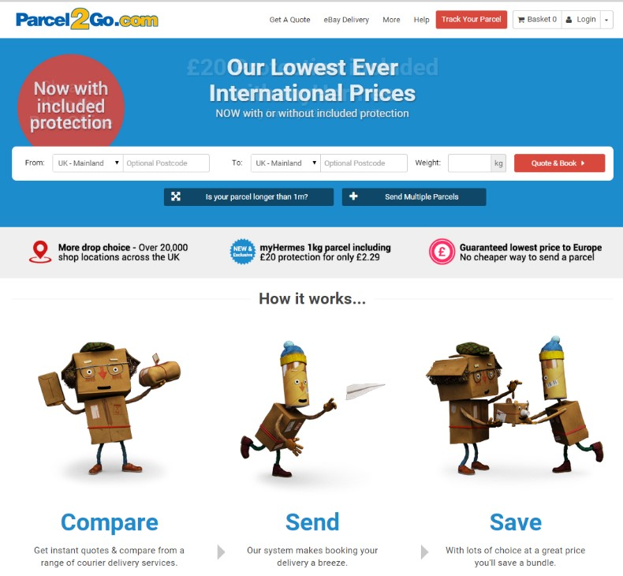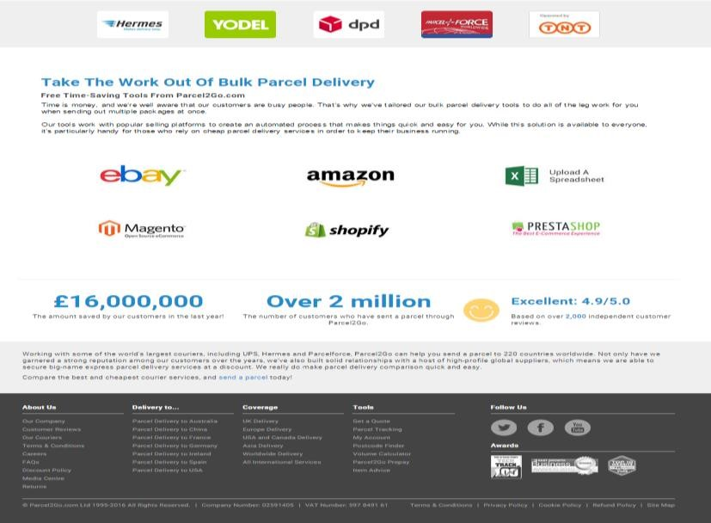

#### Figure 1

17 | P a g e

Parcel 2go design their website in way that is simple and easy to navigate around for the users, as you can see their site is neat and interactive, they choose blue background on top as it symbolizes qualities such as depth, stability, trust, loyalty, wisdom, confidence and sincerity. And white background as this make the site natural. The website have one home page where almost every information needed is displayed for the users. As showing on *“Figure 1”* on top users can get quote which allow them to check the cost of the item they want send and also give them the choice of sending multiple parcel. In here they have some functionalities, which include basket, login and register, text link that navigate you to different pages of their website, on the top left side of the page they have their logo which navigate you back to the home page, images in the middle section of the site and logos used as links to navigate you to companies they cooperate with. At the bottom of the home page they have their rating and comment made by their users and the amount of customers that uses their services over the year.

They also have at the bottom end of the site information about their service and links on social media. This website also offer additional functionalities for registered customers where they are able to view their order history, storing their payment card details, change their personal detail and a prepay balance which allow them to see their balance once they login. In the screen shot in *“Figure 2”* it shows the additional functionalities available highlighted to only registered users.

**Figure**

**2**

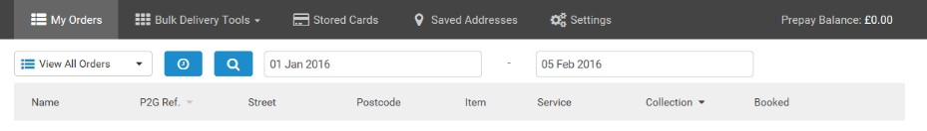

## 4.2 Interparcel

Interparcel website compare to Parcel2go their site is purely simple, the layout of the website is keep natural. The site have khaki background and mix blue and white colours for the site page to keep it simple, and straight to the point, the site is brilliant and easy to read on. The home page displays all the available functionalities they offers, customers are able to access content by using the links available to navigate through the site as showing in screen shot in *“Figure 3”.*

On the right of the page they have their social network links and the logo on the left which take you back to the home page, the site a search box which enable customers to track their items and internal hyperlink which navigate customers to different pages of the site where a much details information is available about their services. They have video link advert and text links that navigate you to other page where customers get clear information about that particular service. The bottom section of the site have information about company network update and news feed about their courier service. Their website have a general functionalities available to all visitors to the site but do not offer customers to register.

At the bottom left of the site they have different companies that cooperate with them and they also have image link about deliveries their contact number for their customers if they need any assistant. The site displays the type of payment method which are accepted at the bottom.

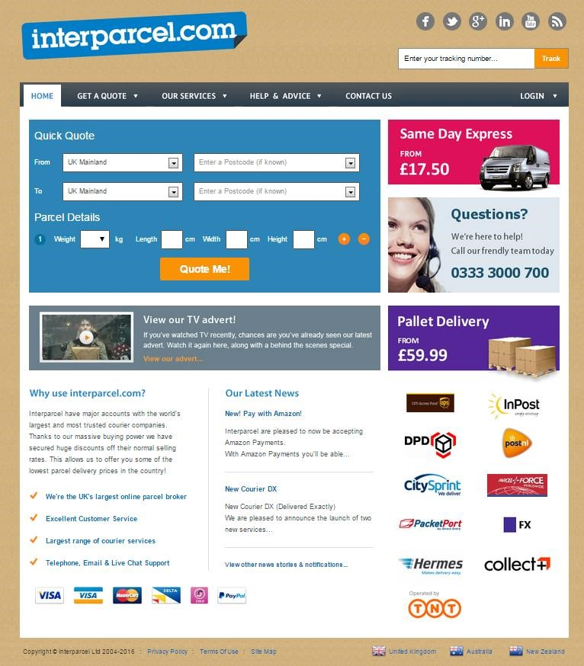

**Figure 3**

## 4.3 Parcel monkey

This website compare to the two on top have different layout and different colour on its home page. This site have green background for the top section with purple used for the get quote the colour green is used as it relaxing to the human eye it help enhance vision stability and endurance, this help them attract more customers, it has text link on top, a search box and a video link as showing in *“Figure 4”*.

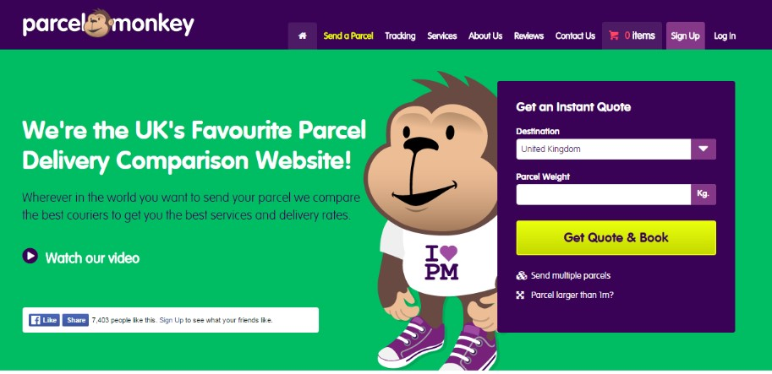

##### Figure 4

The screenshot below *“Figure5”* is the middle section of the site where they have information and images with text link, the links give the customers more information about saving. At the bottom of the middle section the site have shopping cart integration which help customers to save more while using their services.

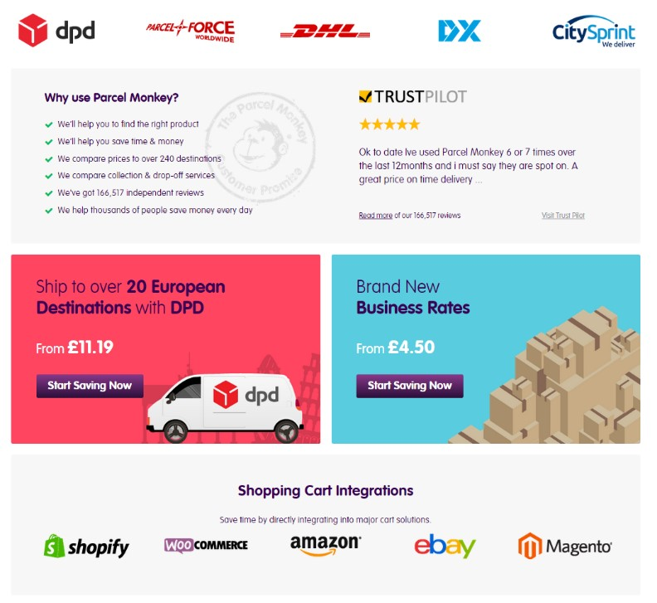

##### Figure 5

The screenshot *“Figure 6”*below is the bottom section of the site which has less functionalities available to the customers, this section only have information and text links about the company and their business services and allow the customers to track their item with account have much more functionalities to interact with on the site.

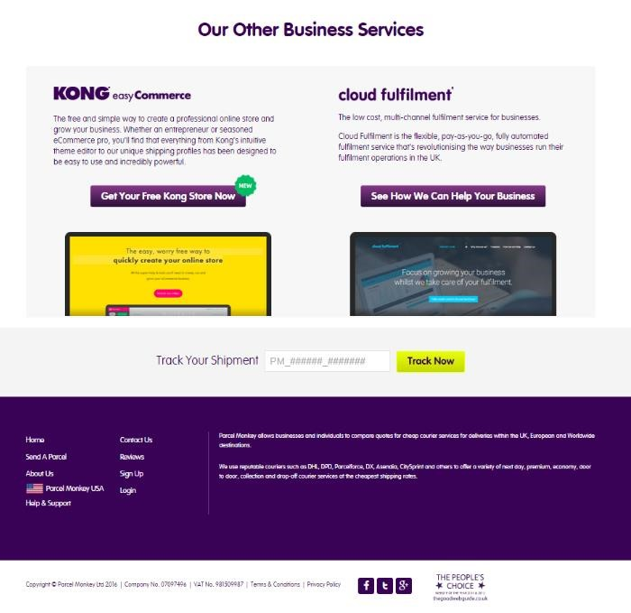

##### Figure 6

This website also offers functionalities that is only available to customers who are registered which allow to perform different tasks e.g. Dashboard, view order invoice, downloading order form prepay and profile settings as showing in *“Figure7”* below these are accessible by a customers who are registered.

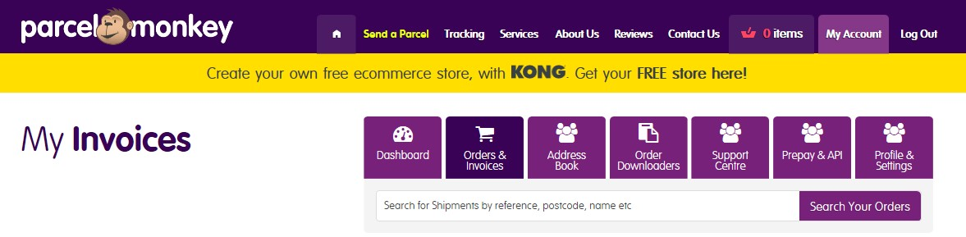

**Figure 7**

## 4.4 Comparison Table

The table show the comparison of existing product using the eight golden rules of Shneiderman’s provide key principal of interface design which is obtained during the research for the project, it ensure application is properly design before used by the audience. A fully explained table of each of the eight principal mentioned here can be seen in the (Appendix – C Page 55)

|  |  |  |  |
| --- | --- | --- | --- |
| **Criteria** |  | **Existing Product** |  |
| **Parcel2go** | **Parcel monkey** | **Interparcel** |
| **Strive for consistency** | ✓ | ✗ | ✓ |
| **Enable frequent users**  **to use shortcuts** | ✓ | ✓ | ✓ |
| **Offer informative feedback** | ✓ | ✗ | ✓ |
| **Design dialog to yield closure** | ✓ | ✗ | ✓ |
| **Offer simple error handling** | ✓ | ✗ | ✓ |
| **Permit easy reversal of actions** | ✓ | ✓ | ✓ |
| **Support internal locus**  **of control** | ✓ | ✓ | ✓ |
| **Reduce short-term**  **memory load** | ✓ | ✓ | ✓ |

## 4.5 Conclusions

After reviewing various existing product, the information gathered from the design identify the role of

HCI and how it has affected the way their website are design to make it interactive, the influence of HCI aid to design good interactive website and helping them gain the benefit of having various functionalities on websites.

The three logistic website compared above have all their sites laid out with balance content and functionalities, they used simple background colour to make it simple. The navigations around all three site is easy however Interparcel do not offer customers to register as the other two website compared in this evaluation. Parcel2Go and Parcel Monkey offers their registered customers additional functionality which enable to them to perform certain tasks which normal user will not be able to accomplish, this is good as it give customers the ability to interact more with website. The two out of the three evaluated existing met the criteria identified in the literature review chapter for this project. However, the third existing in the evaluation could have improved by reviewing it and ensuring that all the guideline mentioned in the literature review are met. The website did not contain an online form for users to register.

As more business are turning online to expand and attract potential customers, it’s beneficial for them to ensure that their website is design to have the feel and look to attract users. Including more interaction on the website will help boost their growth and gained a place in the industry.

However all of the existing product evaluated in this report have their website design to make easy for the user to understand and able to perform task which the site is design for. Therefore it could conclude that logistic website are not only for business build but an environment where engagement and collaboration could be enhance to improve interaction.

# 5 Legal, Ethical and Social and Professional Issues

For the development of this project there are some thing that need to be taking in to consideration to make sure the project do not offend any user’s privacy.

**Legal issues**

The legal issues for this project will be the Data Protection Act 1998 which will ensure the information held by the business to be protected from any other purpose that is illegal and are only used or held for no longer than necessary. The website will tackle this issues by ensuring user are automatically logout once the leave the website page, although the data help in this project at this stage will be sample data there will be no sensitive personnel information about an actual client but the website

The second legal issues concerned for this project Copyright, Design and Patents, as building it involve comparing the functionality and design of similar website in order to develop a better solution for the business. Therefore it is important that all material referred to is correctly referenced to comply with all the copyright Design and patents Acts.

**Ethical issues**

The ethical issues that this project is mainly concerned is the accessibility of the website. As the website will be accessible from a range of platform it to ensure that users get what they expect from the site and ensuring that consistency is keep around all the page to keep a good sense to user. Another concerned for this site will be guaranty that the website have measure in place to protect it user’s privacy from cyber-attacks, hackers who may follow every move which is made online as the online threat is common on website.

**Social Issues**

The social issues this website will concerned with is the race, gender and age. This can avoid by ensuring that once a customer come on the site to register, those requirement are eliminated from the form therefore discrimination against the customers eluded.

**Professional issues**

In order to preserve the professionalism for this project all material that will be used for the development process will be verified and selected appropriately content for the relevant criteria and strict design guidelines will be followed throughout the all design and development process to make sure the project deliver a functional website in a professional manner.

# 6 Designing of “MailSmart” website

## 6.1 Database design

The technology solution for this project will require a secure database in which all information will be store. The database for this project has been designed in SQL Server 2014 Management Studio running on the Microsoft. In order to manage this database the SQL Server Management studio was used within the development process. This was chosen due to its consistency and flexibility that it will offer to the web development. Also the SQL Database platform offer a greater choice in data storage that is much more improved and far superior than services offered through a Database such as Microsoft Access.

The connection between the SQL Server and Microsoft Visual Studio offers a good opportunity for developers to be able to develop their system easily and be able in the future to add or update features within the site. The SQL Server Management studio software allows the database to be taken offline for maintenance if necessary or update, link to new databases for added support with ease with minimum requirements of database management knowledge. This software also helps the end users as the SQL Server Management studio to provide added security for the data held within the database to prevent unauthorized party filching data held within the systems.

## 6.2 Structural Overview

The database for this project consist of 6 table which are design to help deliver the functionalities required for the end user of the website.

The registration Table which will hold all the information for all new registered users.

The Quotation Table which will hold the information regarding any request made for a quote which allow the admin to determine the cost of delivery the services.

Contact table is where data about any issues that customers have concern about the service provided by the business will held.

Sender table which will store the information about anyone requesting for collection

Receiver table store the information about the collected item which then will be used to deliver the item to the appropriate receiver.

Admin table which only hold information about the admin.

## 6.3 Site Layout and Design

The interface design for the “MailSmart” Business has been designed with simplicity in taking into consideration the Nielson web design guidelines found in the research chapter for this project which helped throughout the final design agreed with the client. The website layout design is made simple and easy to ensure that users with less knowledge of IT will be able to use it. The first design were done through hand drawing sketches to get a brief idea on how the final design will appear to users. To achieve this, the site is designed to guide the user through the different task they can perform and taking into consideration the use of helpful prompts and field validation. Below is the screenshot of the web pages design that have been implemented to provide an easy guidance on how to navigate around site without complexity.

## 6.4 Home Page design sketch

The screen-shot below *“Figure 8”* show the design sketch of the website home page that was heavily influenced by the research done on the existing product home page to ensure that users can adapt to the new system while sustaining the quality of the design by taking into consideration the standard guidelines of navigation structure and colour scheme to help the user get the website content easily.

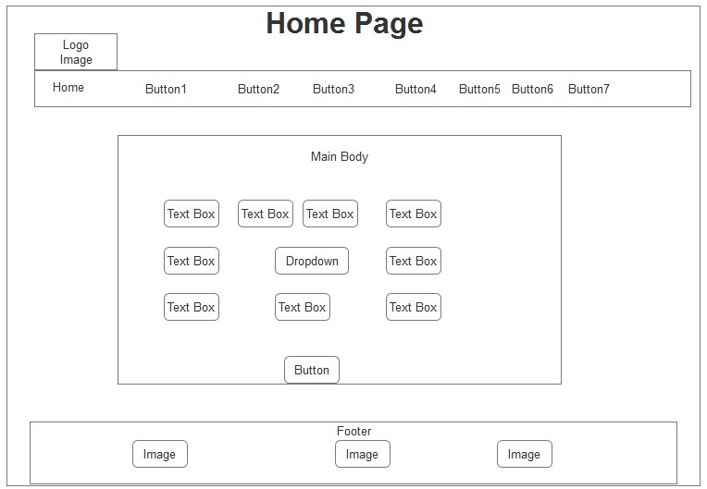

**Figure 8**

## 6.5 Coverage Page design sketch

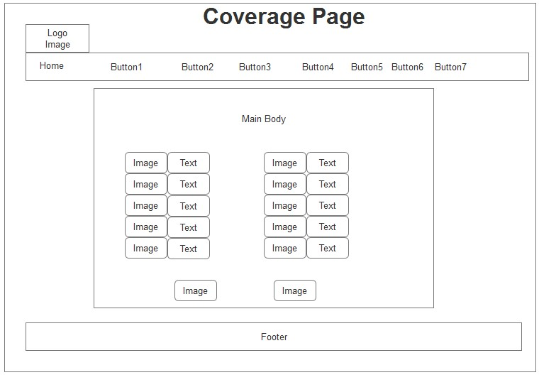

#### Figure 9

The above screen-shot *“Figure 9”* show the design sketch of the website Coverage page of the *“MailSmart”* Website, the design was persuaded by the research done on the existing product such as *Parcel2Go, Interparcel* in order to ensure its unique layout and maintaining the quality of the design and helping the users to adapt to the new design structure of the “MailSmart” Business site. The advantage of this layout is to eliminate confusion and making the user is well clear about the information displayed and the aim of it.

## 6.6 Business to Business Page design sketch

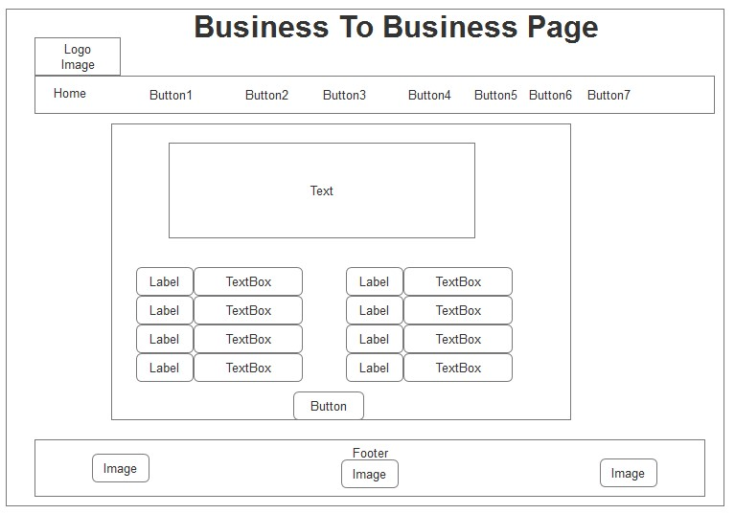

#### Figure 10

The above screen-shot *“Figure 10”* show the design sketch of the Business To Business page of the *“MailSmart”* Website, the design was persuaded by the research done on the existing product in order to ensure it has a unique layout is accomplished and ensure that a quality design is maintain to facilitate the users to adaptation to the new design structure of the site.

Considering clients who are not very IT literate, the researcher felt that these design techniques would help them to better understand the different functionality included within the tool, helping the client to become efficient and effective whilst using the tool a lot quicker.

## 6.7 About Us Page design sketch

The screen-shot below *“Figure 11”* show the design sketch of the About Us page for *“MailSmart”* the design closely explored the research done on the existing product in order to ensure the layout help the user’s adaptability while preserving the quality of the design by taking into consideration the standard guidelines gained during the research on the existing product.

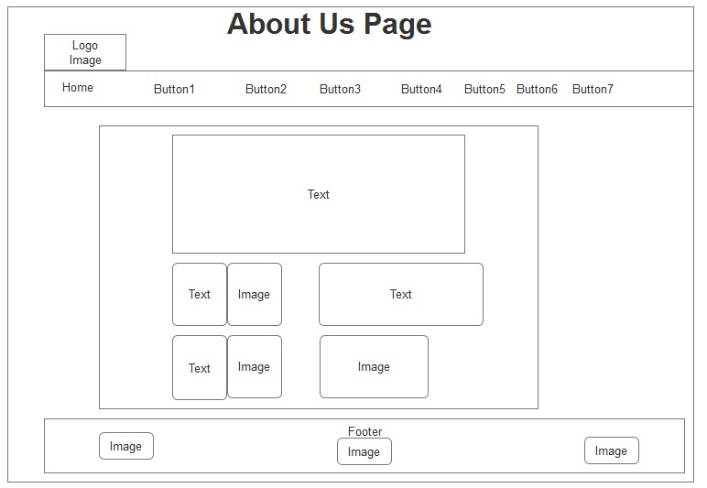

**Figure 11**

## 6.8 Contact Us Page design sketch

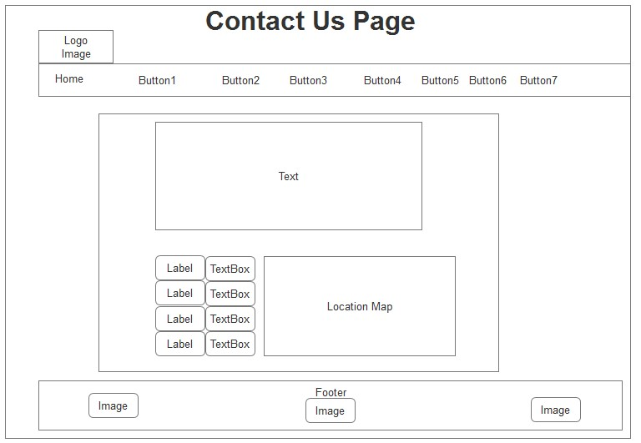

#### Figure 12

The screen-shot above “Figure 12” show the design sketch of the Contact Us Page for the “MailSmart” Website, the design was influenced by the research done on the existing product in order to ensure a consistent layout for the user and maintaining the user familiarity with the design structures of the existing product.

## 6.9 Login and Registration Page design sketch

The screen-shot below in “*Figure 13, 14*” show the design sketch of the Login and registration Page of the *“MailSmart”* Website, the design was inspired through by the research done on the existing products in order to ensure the user can adapt to the layout structure easily as they are prone to be familiar with the design of the two webpages which help maintain the quality of the design.

|  |  |
| --- | --- |
|  |  |

**Figure 13** **Figure 14**

## 6.10 User Account and Admin Page design sketch

The two screen-shot below in *“Figure 15, 16”* show the design sketch of the User and Admin Page of the *“MailSmart”* Website, the design layout structure is made simple for the user, this was motivated by the research obtained on the existing product such *Parcel2Go*, *Interparcel* and *Parcelmonkey* as they users will be prone to be familiar with the design which help the user to have a better understand the different functionality included within the design, helping the client to become efficient and effective whilst using the tool a lot quicker.

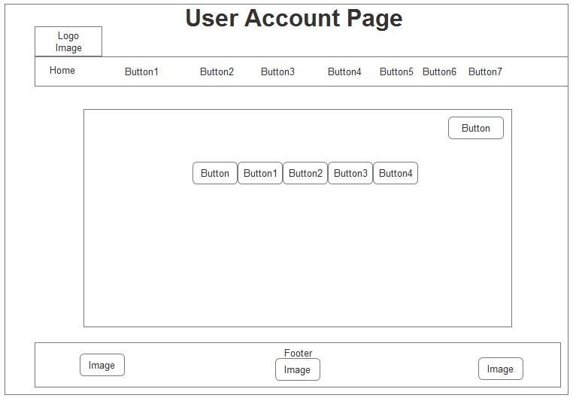

#### Figure 15

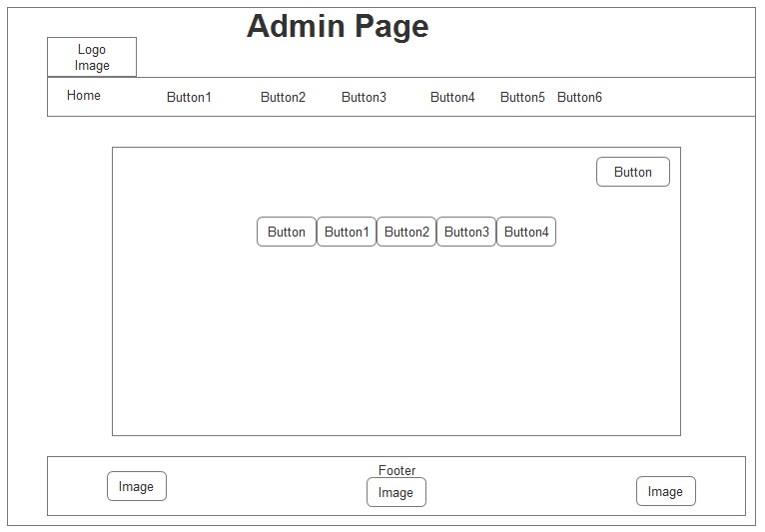

**Figure 16**

## 6.11 Colour Scheme

The scheme used for the “MailSmart” website is simple, this was inspired by the research and the reviewing of existing product. Due to simplicity and the flexibility it’s offered this was chosen for the “MailSmart” Business site to help make its layout look attractive without having any accessibility concerns for the familiar and potential user. The colour chosen is to ensure that it’s make site have its unique layout outlook.

# 7 Development Process

The “MailSmart” website development process was well carried out using a planned process. Once the requirements and the design layout were finalized. The development was transferred to structural approach to ensure that each milestone can be accomplished within the project life cycle in a timely manner using a Gantt chart which can be seen in the screen-shot below**.** A much more detail of the Gantt chart can be seen in (Appendix –B Page 54).

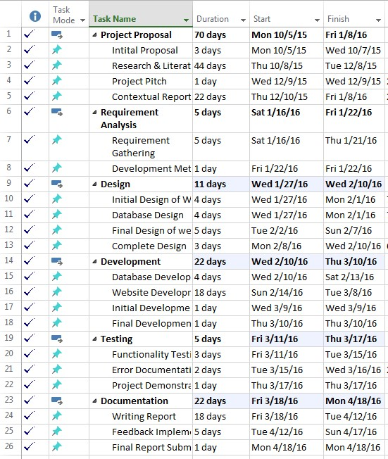

### 7.1.1 Use case

The “MailSmart” site functional model was broken-down into section that can be easily demonstrated using Unified Modelling Language (*UML*) technique. This was discuss with the client during the initial requirements gathering meeting, the design demonstrate the functionality given to process in must details. This also help understand the vital functional behaviour of the design system while assisting to better understand the operation of each process. It was established that the user will be able to request for a quote, register, sign in and amend details, View history of quotation also to make an enquiry, it was established that the Admin will be able to view quotation, create price and respond to enquiries. A full much more detail of the function process could be seen in the screen-shot below *“Figure 17”*.

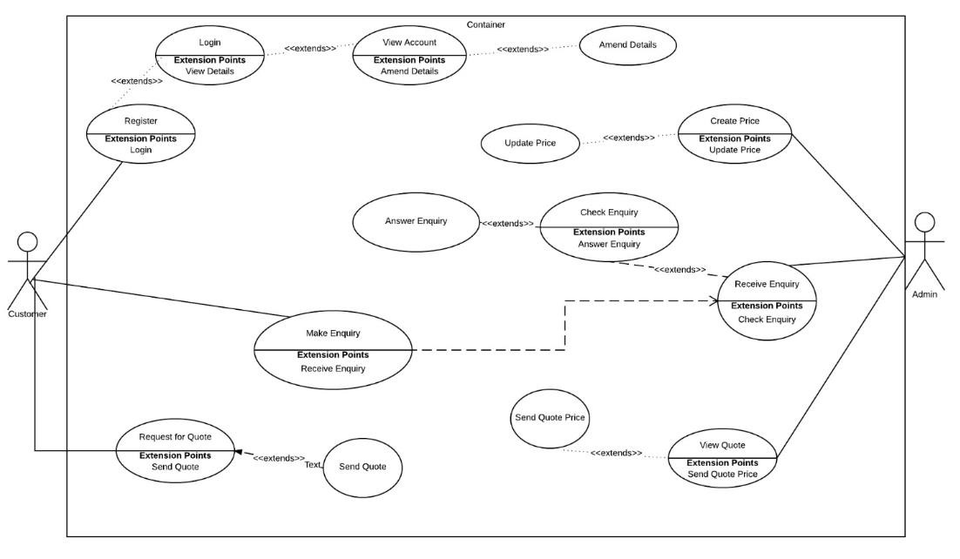

**Figure 17**

### 7.1.2 Class Diagram

The Class Diagram of the “MailSmart” system shows the class the system, theirinterrelationship and the operation and attribute of the each of the classes. This will make it easy to write the code of the system and also help understand the vital operation and the attribute of each class. This has been done in order to aid the client to understand the operation of each class. The design of the class diagram of the system is descript in the screen-shot below *“Figure 18”*.

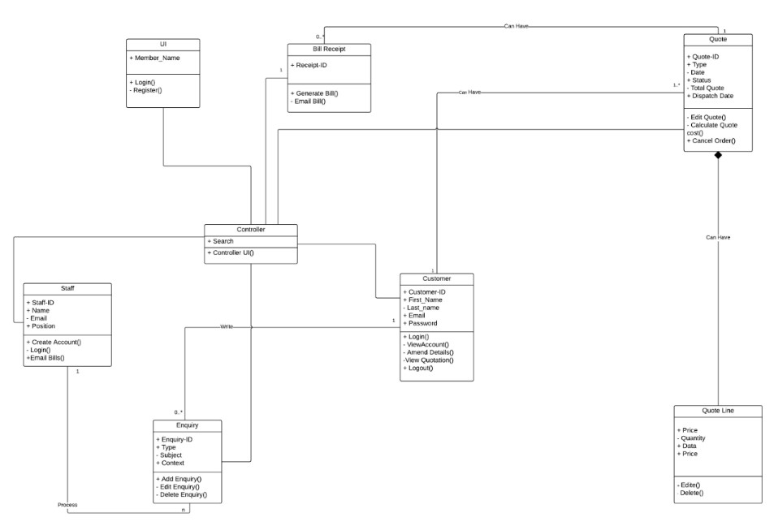

**Figure 18**

### 7.1.3 Database

The registration Table which will hold all the information for all new registered users, Quotation Table which will hold the information regarding any request made for a quote which allow the admin to determine the cost of delivery the services, Contact table where data about any issues that customers have concern about the service provided by the business will held and Sender table which will store the information about anyone requesting for collection where the Receiver table store the information about the collected item which then will be used to deliver the item to the appropriate receiver. The full ERD design of the database could be seen in *“Figure 19”* below.

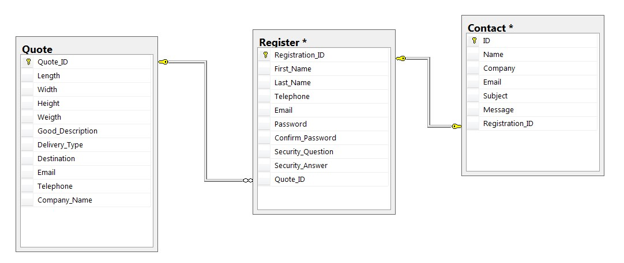

**Figure 19**

### 7.1.4 Time Box

|  |  |  |
| --- | --- | --- |
| **Task No** | **Task** | **Task Status** |
|  | Initial Research study | Completed on time |
|  | Requirements Gathering | Completed on time |
|  | SQL Database Design | Completed on time |
|  | Website Layout Design | Completed on time |
|  | Development of Database | Completed on time |
|  | Master Pages design and Homepage development | Completed on time |
|  | Registration page development | Completed on time |
|  | Verification Email | Did not complete as planned due to code complication and errors during implementation |
|  | Login Control Implementation | Could not complete on time due code error and the time boxing delayed by 1 day. |
|  | User Account design | Completed on time |
|  | User Amend details | Could not implement this functionality due to the code complication and the time schedule for the project, this could be implemented after the project been delivered on it set date, as they most important functionalities has |

|  |  |  |
| --- | --- | --- |
|  |  | been implemented this will not have an effect and will done before the site is up and running. |
|  | Customers to be able to request for quotation | Completed on time |
|  | Password Encryption | Completed on time |
|  | View Quotation History in user account | Due to the code complication and the time schedule for the project, this functionality was not implemented. This will implemented after the project been delivered on it set date, as they most important functionalities has been implemented this will not have an effect and will done before the site is up and running. |
|  | Contact Us page | Completed on time |
|  | Admin Account Design | Completed on time |
|  | View Quotation request in Admin page | Could not implement this functionality due to the code complication and the time schedule for the project, this could be implemented after the project been delivered on it set date, as they most important functionalities has been implemented this will not have an effect and will done before the site is up and running. |
|  | View Enquiry in Admin page | Could not implement this functionality due to the code complication and the time schedule for the project, this could be implemented after the project been delivered on it set date, as they most important functionalities has been implemented this will not have an effect and will done before the site is up and running. |
|  | Testing of functionalities | Completed on time |
|  | Fixing Errors | Completed on time |
|  | Presentation | Completed on time |
|  | Final Report | Completed on time |
|  | Final Product | Completed on time |

### 7.1.5 Development Tools

In order to develop the new “MailSmart” Business site interface design a workable prototype were design that meet all the requirement of the project. Microsoft Visual Studio 2013 was used following the programming language of C# (*C Sharp*). This was chosen due to my experience gained using it during my second year of studies, it’s flexible and effective which make it easy to integrate with the backend database together with the website while working to accomplish the needed requirement of the user in a well-timed approach.

## 7.2 Implementation of functionalities

### 7.2.1 Home Page

This page allow potential customer to navigate around the website but with limited access to certain functionalities which can only be access by registered users, it permit a potential user to request for a quotation by filling the required field on the page, which then will be received by the admin by an email. The CSS code used to implement this functionality cane be seen in the screen-shot below *“Figure 20”* , which explain each selection of the code, this will then be receive by email, it will be assess by the admin to determine the price, which will be then emailed back to the customer. A screen-shot of the CSS code implemented for the “Home page” can be seen in below in *“Figure 20,*

*21”*.

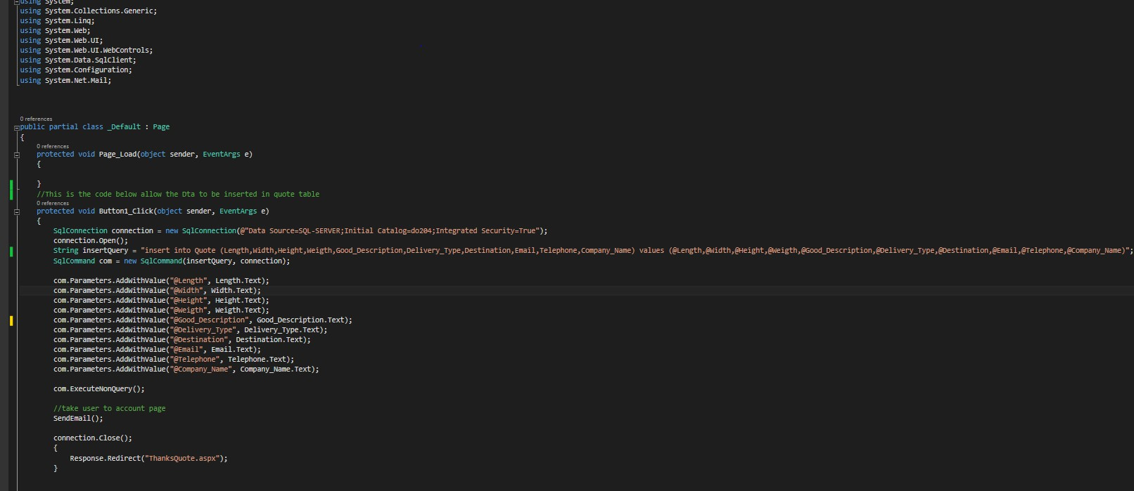

This CSS code highlighted is used to

allow the connection to the SQL

Server Management Database, this

allow data to be inserted to the Quote

table.

This CSS code is used to

support the

email sending.

##### Figure 20

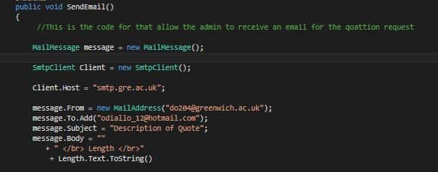

This CSS code highlighted

shows the email address

of the admin and the

sender, in this case as the

university server were

used it’s only a single

email address to be used

as sender email.

**Figure 21**

### 7.2.2 Register (CSS code)

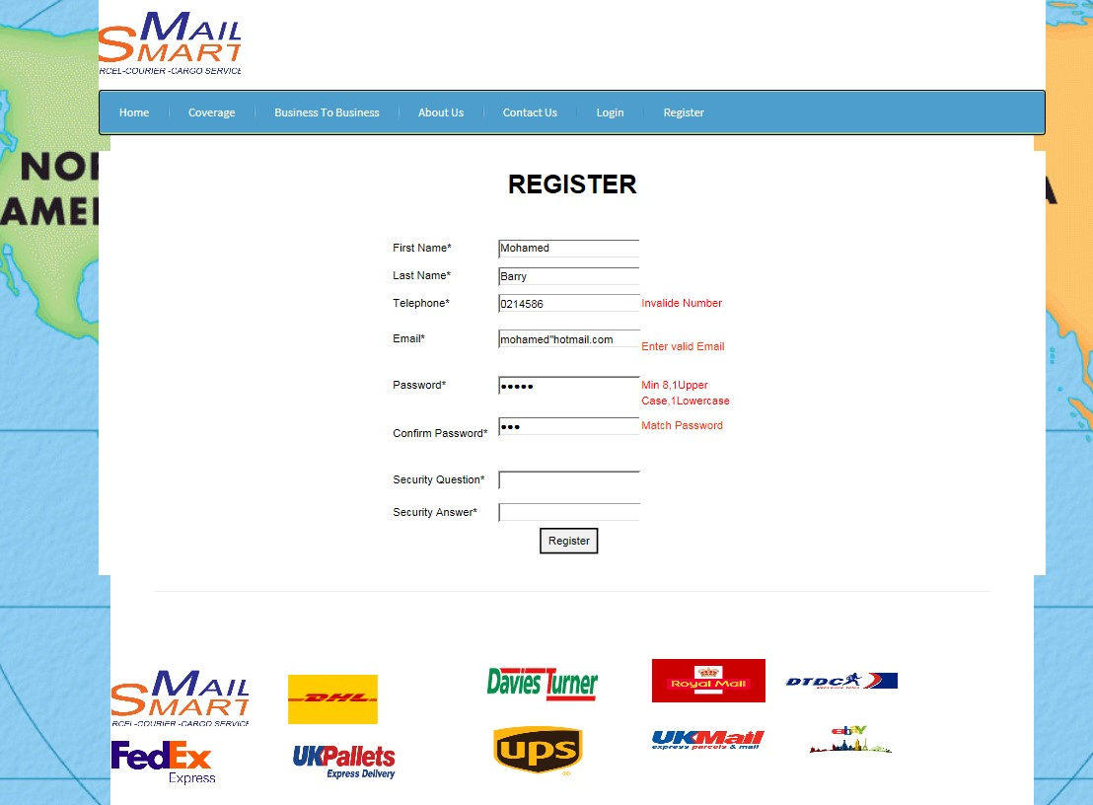

##### Figure 22

The registration page has been implemented for the site so that it will allow new user to sign up for an account with the “MailSmart” Business. In order to ensure that any data entered is well protected a heavy validation rules were used to ensure all required field are fill with appropriate data as showing in *“Figure 22”* and a verification email to ensure all provide email can be verified. This is done to provide a good security measure and only valid email is accepted as it shows on the screen

–shot above. To verify the email *“Regular Expression Validator”* were used and the validation expression is set to ensure that only valid email can be entered. For the Telephone field same validation is used to ensure only UK numbers van entered.

The Password and Confirm Password used *“Compare Validator”* is also applied to ensure password used match. To ensure a good security is implemented, the user password were encrypted to make it difficult hack the customers login details, the code used for the password encryption can be seen in

*“Figure 26”.*

Once a User complete the form with appropriate data, a message will appear to show that their registration has been successfully completed as showing in *“Figure 23”* below , while given them further instructions to verify and activate their account to able to login.



**Figure 23**

After successfully the account has been created an email is sent the new registered user inviting them to verify their account and activate their account by clicking on a URL. A CSS code used for the functionality can be seen in the screen-shot below *“Figure 24”*. This is shown on the screenshot below. Notice the user’s name provided is attached to the email in order to personalize the addressing of the email. If a User does not follow the process they will not be allowed to login to their account. This implementations is one of the most fundamental within this project to secure the privacy of users as well protecting them against fake users.

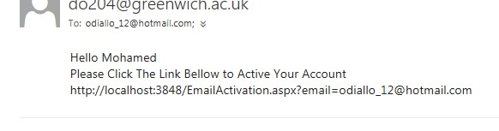

##### Figure 24

Once the user clicks on the URL link, their account will be activated giving them ability to login and access the user account page, by using their email and password. The CSS code used to implement this functionality can be seen below in *“Figure 25, 26”*.

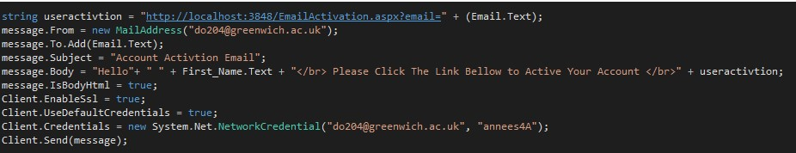

##### Figure 25

|  |  |  |
| --- | --- | --- |
|  | |  | | --- | | This is the CSS code used to encrypt the user password | |

**Figure 26**

### 7.2.3 User _Account View

The screen-shot below *“Figure 27”*showcase the User Account page as it was design according to the site design sketch discus in the design section report.

On the top right of the page it show the user email address and the logout button, which give them the option to sign out at any time. It also shows button links that will navigate the user to different internal link of the site, the *“View & Update Details”* which allow the user to amend their details, those details will be updated automatically in the Registration table of the database, the *“View History”* button that enable the user to view history of their quote request displayed also the *“Support Centre”* which will displays admin contact details for the user if any problem that admin should be informed.

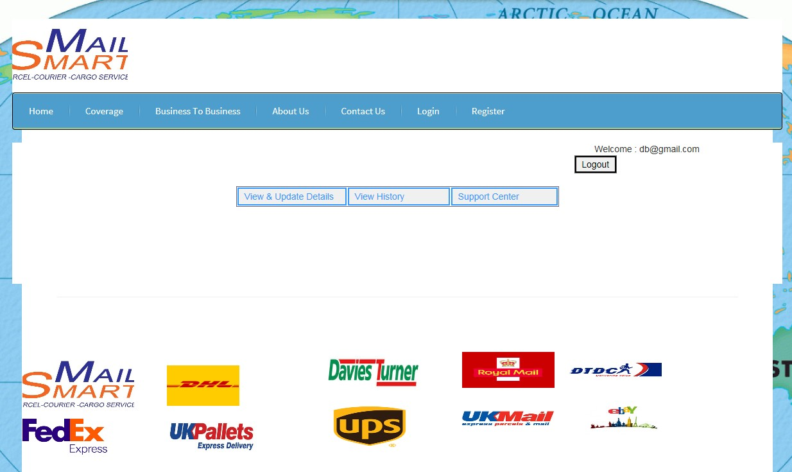

**Figure 27**

### 7.2.4 Contact Us Page

The Contact Us page has implemented to allow potential user to be able to contact and find the location of the “MailSmart” Business as seen in *“Figure 28”,* if they have any concern while using the site. It shows the address and contact details and also a map to make it easy to locate it as it demonstrate on the screen-shot below.

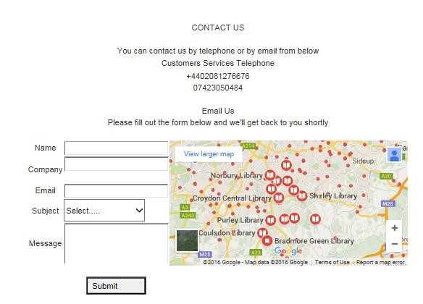

**Figure 28**

### 7.2.5 Admin

The screen-shot below *“Figure 29”* showcase the User Account page as it was design according to the site design sketch discus in the design section report. It shows buttons links that will navigate admin to different internal link of the site, the *“View Collection”* which allow the admin to view all request for collection full details, the *“View Quote History”* button that will show history of all quote request displayed also the *“Complains”* which will displays all they issues customers have send to the admin.

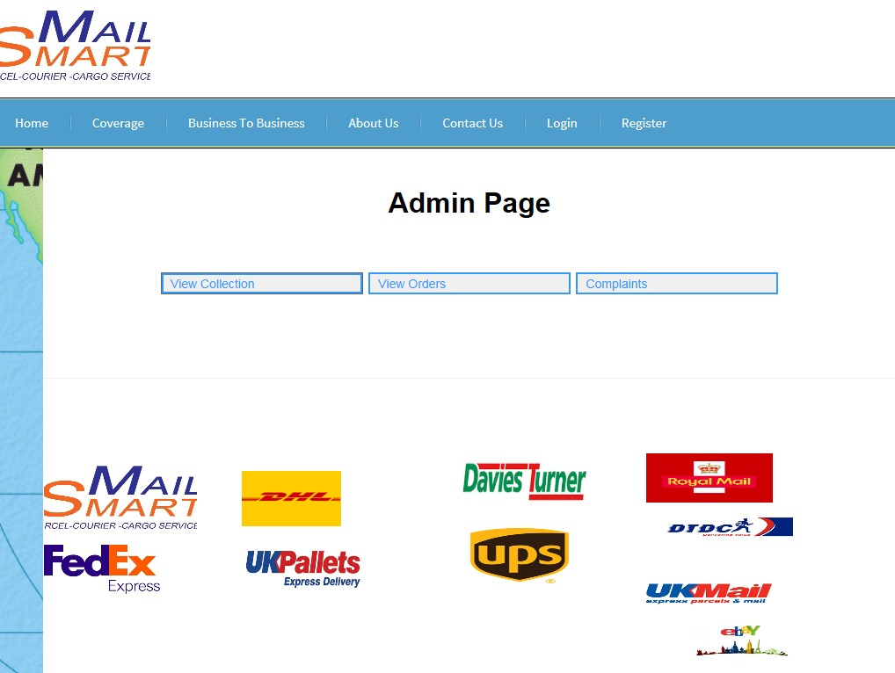

**Figure 29**

# 8 Testing

The examining and verification testing used to evaluate the usability and accessibility as mentioned in the research part of the report of the solution with the client was very useful and effective. The testing for the validation used for the “MailSmart” Business website were reliable and could be improved to ensure the security of the website will be more effective for the users as “MailSmart” is focusing on user experience, this was influenced by the result obtained in the research section of the report. However some of the validation could have been improved before the demonstration as there were a few issues which were not discovered during the project demonstration. Therefore intense validation testing could have been carried out and be improved prior to the demonstration.

All the criteria and testing which were carried for the “MailSmart” Business website could be seen in well explained details in (Appendix D Page 56).

# 9 Evaluation

## 9.1 Evaluation of Product

The intend for the final product of the “MailSmart” website was to deliver a set of requirements that will enable users to interact with website, to ensure that possible solution can be implemented for the “MailSmart” website an intensive research and analysis were carried out. The result gained from the research immensely assisted in the finding of key requirements and potential functionalities that can be implemented to the development of the website.

Although the website has been developed to be a fully functional prototype that has the functionality suitable to implement as a workable system some of the “Should have” functionalities which should implemented for the user and admin account were not fully implemented in the website due to time constraint, it could be stated that the implement functionalities at this stage has been developed in a manner that allows the developers to improve the quality further and ensuring these can be functional also extra functionality and modify the existing content in the future.

All the functionalities identified during the research for the system were considered equality crucial for the user experience, the security features implemented in the system to validate the user entered data “Email Verification and password encryption” is thought to be significant implementation for the website. These features were vital to be applied in the website to ensure that it can be protect from unauthorised registration, access and also from hackers. A full explanation of this functionalities can be seen in the development chapter of this report.

The “MailSmart” website has been designed and developed to provide the targeted end user with the required functionality and make much interactive. There are many solution gained during the research that will benefits the end user which have been illustrated in research chapters in this report some of the main benefits have been briefly evaluated below.

#### Recognition rather than recall

The developed product was targeted at potential users to enhance the engagement with website through a presence of an exclusive online logistic network that would allow the users to interact, enable the user to perform action and have option visible to them without having to remember information and allow to retrieve information when needed. The new website has been developed to provide this functionality to the user alongside security features that were implemented to protect the privacy and accuracy of data used by the members of the site.

#### Flexibility and efficiency of use

The *“MailSmart”* Website has been designed to allow the user to adapt frequent actions. As less familiar users may often speed up the interaction than the expert users, the system can the system to both inexperienced and experienced users. Allow users to adapt frequent actions which help improve the interaction between the user and the system.

#### Help user recognise

The *“MailSmart”* Website has been designed to help users identify errors made while using the site. As less familiar users may often speed up the interaction than the expert users, this can provide to both inexperienced and experienced users a good understanding about their wrong doing and correct it before performing the any action.

Overall *“MailSmart”* has been successfully completed with a design that cater the intended users with the required functionality while taking into consideration the guidelines on design principal obtained from the research chapter to aid achieve the maximum functionalities through the development of the website.

## 9.2 Future Development

For future development a number of functionalities and development have been propose for the website, below are propose future development which can be implemented on the website:

### 9.2.1 Responsive design techniques

This future will ensure the website can accommodate different devices and attract potential clients who may use to access the “MailSmart” website. This will make easy for the user to interact with the website on different range of devices, and also will contribute to the growth of the business as a vast amount users will be able to access the site on their gadget. Responsive Website make the user experience to spend a lot more time on a website through their device of choice and preference anytime and the website content will display the same result as in desktop computer screen.

### 9.2.2 Enabling Payment Method

The implementation of the payment method on the website to enable clients to make payment while on the website, this will facilitate the user the time consuming that will taking to user the current payment method which uses an application. Users will be able to store their payment details on the user account once registered.

### 9.2.3 Tracking System

The tracking system method functionality will implemented as future development to enable customers to track their item so that there is need to wait or make phone calls to find out if their item has been dispatch or to know the waiting time before receiving their item.

### 9.2.4 Mobile Application

The mobile app development future for the “MailSmart” Business will help the Business as nowadays more and more small and medium size business are following the mobile trend as more people have a smart phone, this will help with the direct marketing as all information users need to know is provided to them which shows that you providing value to your customers and cultivate customers loyalty.

Implementing this mobile app will contribute massively in the brand and recognition of the “MailSmart” Business, improve customer engagement with the website and stand out from the completion by offering the mobile app.

## 9.3 Self-Evaluation

The initial thought of developing the “MailSmart” Business website was envisage by the client in interest that it will make the website much more interactive for potential and registered users and help boost the business growth. After carrying out research study on web interaction and usability through online and books, some possible key solution were identified that could be implemented to solve the problem confronted in the “MailSmart” website. The methodology and project planning tools used for this project were beneficial as it help deliver the product in the set deadline while accomplishing the main functionalities required for the project.

In the development of the project planning and designing stages one of the challenging processes was getting the layout in place in order to make simple so that users will be able to navigate and interact easily on the website. This issue was solved with the guidance of result attained from the intensive research. This has aided in making the design decisions for the end product be attractive, simple to navigate and much more interactive for the user not having to compromise on the whole design of the website.

During the development process one of the most challenger sector faced was handling the complex code for the some of the webpages of the website the “Home Page” where users can request for Quote to implement this functionality appropriately vital to ensure the functionality desire will work as expected. This issue took a lot of time to solve than other functionality during developments which altered the time schedule while it needed the problem solved. However the issue and others uncounted were overcome through extensive research on C # sharp programming tutorials and websites finding which resulted in a much broader understanding of the programming language, which assisted in keeping the development of other functions operation efficiently while aiding to broaden personal knowledge of the coding side and better understanding of the C# programming language.

If this project were to be repeated again, I would spend more time defining the scope of the project as I found that my interest got away with me at the beginning thinking this will be too big to achieve within the time set for the deadline; I would put more time in advance learning the C# sharp programming language and other open source software available to use before starting the development in order to reduce the amount of time that had been spend learning the code to develop certain functionality of this project while the development was in progress. The simpler functionality would have been implemented faster which will give more time to spend and revise skills learned on the implementation stage of the major functionalities of the project. This would allow me to build a stronger, more thorough test plan; to ensure that the solution was tested carefully so that any issue can be identified sooner rather than later.

However this this project has assisted massively in developing new sets of skills throughout planning and development while supporting a wide knowledge in using extensive research findings effectively to a problem and implementing those finding throughout the development of the project. Developing this project has also increased the understanding of the C# sharp programming language natures and SQL databases and augmented the passion to learn further more in depth and work much more effectively while able to cope with the time. In addition the development of this this project has been a generally a considerable learning experience that boosted current skill academically as well as professionally.

# 10 Conclusion

This report evaluated the techniques used for the development of the “MailSmart” project pointing out all the vital keys within the project. This project had come across difficulties during research and the development, during the research I found the areas for this project motivating even though some were confronted during the writing of the literature which was finding the solution needed for problem the project was encountering, this was tackled by doing an extensive research on the literature review. The implementation for the project was less worrying due to previous experience gained using the programming languages C# sharp during the second year of studies although some tutorial followed to facilitate the implementation of some required functionality for the project.

The finding of the research carry out on the research section have been taken into account which contributed massively toward the development of the final product. The development of this project has been an important journey as a lot been learnt about the C# sharp programming languages and SQL Server Management in depth and new techniques were used in the implementation of the website, and these important skills gained during this project development can be applied to another project in the future.

This project functionalities implementation was time consuming due to the research which needed to conducted to find the appropriate solution and the code complexity of certain web pages of the site, much of the time were spend on research due to that the implementation of the planned functionalities on the project were not applied, the report side of the project has taken a considerable amount of time although the final product is as much important as the report.

Due to the time set for the project**, i**t was accomplished within the given time frame by following the “DSDM” Development and project planning tools which helped with the time management right through all the process of the project, although some functionalities that would have benefited the website weren’t implemented but were listed as future improvements and development. Most of the time during the development was spent on the main functionalities of the website such as the ability to request for Quote, register and able to contact the admin.

Overall the delivered product fulfill all the requirements and functionality required for the site to be up and running and taking into consideration all the possible issues legal, social, ethical and professional.

# 11 References

Abou-Zahra, S. (2008). Web Accessibility Evaluation. Human-Computer Interaction Series, pp.79106.

Butleris, R. (2015). Towards implementing a framework for modeling software requirements in MagicDraw UML. Information Technology and Control.

Chisholm, W. and Henry, S. (2008). Interdependent components of web accessibility. Proceedings of the 2005 International Cross-Disciplinary Workshop on Web Accessibility (W4A) - W4A '05.

Cooper, A. (1999). The Inmates Are Running the Asylum: Why High-Tech Products Drive Us Crazy and How to Restore the Sanity. indiana: Cooper, Alan.

Dandy, W. (2013). Web Site Accessibility | Accessibility Site Audit. [online] Webdandy.co.uk. Available at: http://www.webdandy.co.uk/accessibility-audit/ [Accessed 29 Nov. 2015].

Danino, N. (2007). [online] Sitepoint. Available at: http://www.sitepoint.com/computer-interactionsite/ [Accessed 7 Dec. 2015].

Day, T. (2013). Success in Academic Writing. Palgrave: Palgrave.

Dix, A., Findy, J. and Abowd, G. (2004). human computer interaction. delhi: pearson education.

Dix, A., Finlay, J. and Beale, R. (2004). Human computer interaction. Harlow: Alan dix, Janet finlay, gregoryD, Abowd, Russell beale.

Forbes.com. (2013). Forbes Welcome. [online] Available at: http://www.forbes.com/sites/allbusiness/2014/11/17/heres-why-your-business-needs-its-ownmobile-app/#1eb4d6ee5c76 [Accessed 12 Feb. 2016].

Forbes.com. (2014). Forbes Welcome. [online] Available at:

http://www.forbes.com/sites/allbusiness/2014/11/17/heres-why-your-business-needs-its-ownmobile-app/#1eb4d6ee5c76 [Accessed 9 Mar. 2016].

Human factor in computing system. (2011). Vancouver,BC, Canada: Bargas-Avila, J.A., & Hornbæk, K, pp.2689,269.

Jstor.org. (2016). JSTOR: Search Results. [online] Available at:

http://www.jstor.org/action/doBasicSearch?Query=visual+design+on+website&prq=visual+design &group=none&so=rel&wc=off&hp=25&fc=off&acc=on [Accessed 8 Dec. 2015].

Jstor.org. (2016). The “Visual Preference Heuristic”: The Influence of Visual versus Verbal Depiction on Assortment Processing, Perceived Variety, and Choice Overload on JSTOR. [online] Available at:

http://www.jstor.org/stable/10.1086/673521?Search=yes&resultItemClick=true&searchText=visual &searchText=design&searchText=on&searchText=website&searchUri=%2Faction%2FdoBasicSea rch%3FQuery%3Dvisual%2Bdesign%2Bon%2Bwebsite%26amp%3Bprq%3Dvisual%2Bdesign%2 6amp%3Bgroup%3Dnone%26amp%3Bso%3Drel%26amp%3Bwc%3Doff%26amp%3Bhp%3D25 %26amp%3Bfc%3Doff%26amp%3Bacc%3Don#full_text_tab_contents [Accessed 13 Dec. 2015].

Lengel, J. (2002). The Web wizard's guide to multimedia. Boston, MA: Addison Wesley, p.50.

Mattsoave.com. (2012). Usability Evaluation of IU.edu | 5. Error Prevention. [online] Available at: http://mattsoave.com/old/cogs187a/iu_site_eval/5errorprev.html [Accessed 13 Mar. 2016].

Nawaz, A. (2014). Definitions of User Experience and Usability | User Experience Professionals Association. [online] Uxpa.org. Available at: https://uxpa.org/resources/definitions-userexperience-and-usability [Accessed 20 Dec. 2015].

Nngroup.com. (2016). Why You Only Need to Test with 5 Users. [online] Available at:

http://www.nngroup.com/articles/why-you-only-need-to-test-with-5-users/ [Accessed 28 Nov. 2015].

Portocarrero, J., Delicato, F. and Fuentes, L. (2014). Autonomic Wireless Sensor Networks: A Systematic Literature Review. Journal of Sensors.

Pubs.cs.uct.ac.za. (2016). UCT CS Research Document Archive - Improving web interaction in small screen displays. [online] Available at: http://pubs.cs.uct.ac.za/archive/00000194/ [Accessed 16 Dec. 2015].

Rouse, M. (2010). What is HCI (human-computer interaction)? - Definition from WhatIs.com.

[online] SearchSoftwareQuality. Available at: http://searchsoftwarequality.techtarget.com/definition/HCI-human-computer-interaction [Accessed 5 Jan. 2016].

Rudestam, K. and Newton, R. (2010). Surviving your dissertation. SAGE, p.105.

Shelton, C. (2012). [online] Available at: http://users.ece.cmu.edu/~koopman/des_s99/human/#hci [Accessed 6 Jan. 2016].

SitePoint. (2009). Human-Computer Interaction and Your Site. [online] Available at: http://www.sitepoint.com/computer-interaction [Accessed 2 Dec. 2015].

Smith-Atakan, S. (2006). Human computer interaction. Middlesex: Middlesex University Press.

Userbrain Blog. (2015). Website Usability Testing: 7 ways to make it a habit. [online] Available at: https://userbrain.net/blog/website-usability-testing-make-habit [Accessed 10 Nov. 2015].

Uxbooth.com. (2015). Complete Beginner's Guide to Interaction Design | UX Booth. [online] Available at: http://www.uxbooth.com/articles/complete-beginners-guide-to-interactiondesign/#what [Accessed 28 Nov. 2015].

Uxpa.org. (2014). Definitions of User Experience and Usability | User Experience Professionals Association. [online] Available at: https://uxpa.org/resources/definitions-user-experience-andusability [Accessed 17 Dec. 2015].

W3.org. (2012). Developing a Web Accessibility Business Case for Your Organization: Overview. [online] Available at: http://www.w3.org/WAI/bcase/Overview [Accessed 12 Dec. 2015].

Web site accessibility: an online sector analysis: Information Technology & People: Vol 17, No 1.

(2013). Information Technology & People. [online] Available at: http://www.emeraldinsight.com/doi/full/10.1108/09593840410522198 [Accessed 30 Nov. 2015].

# 12 Appendices

## 12.1 Appendix A- Project Proposal

**COMP1682 Project Proposal**

**Building a Logistic Website for a Small Mail & Cargo Business** **Ousmane Diallo**

**BSc H BUSINESS COMPUTING-UG**

**000748942**

**Overview**

This project will examine the changes which need to be taken into consideration when implementing technology solution in logistic website, to ensure that the applied solution are successful, engaging and suitable for the type of environment to which it applied and to the customers. The examination aim is to bring together a list of requirements for the technology solutions which will be used within a logistic website situations.

The project will then apply the techniques to develop a prototype website for a start-up logistic website. The developed website will be tested against the list of requirements, with the aim of determining customer’s expectation and making it interactive for user within the logistic domain.

**Aim**

The aim of this project is create a website site with combined techniques and features from existing websites that contribute to the suitability and success of the small start-up business.

**SMART Objectives**

**Research**

Read online information

Research and compare different website

Analysis information

**Requirement**

Ask question

Create rich picture

Functional & Non-functional requirements

**Design**

Create ERD Diagram

Logical Diagram

**Implementation**

Create the system based on ERD and storyboard

**Testing/validation**

Run program

Check the system work as expected

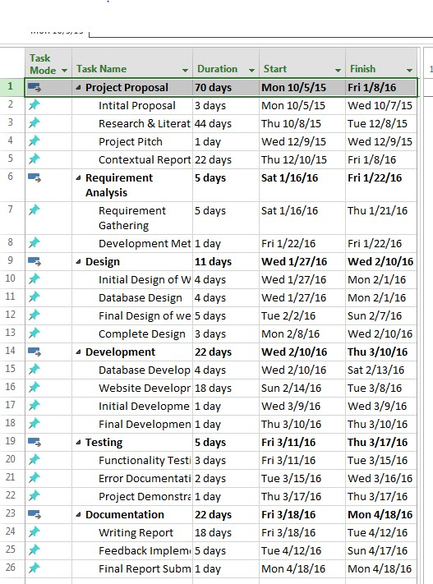

**Legal, Social, Ethical and Professional**

**Ethical issues**

The ethical issues for this will to be ensure that the website have measure in place to protect it from cyberattacks, hackers who may follow every move which is made online.

**Data Protection Act 1998**

The legal issues for this project will be the Data Protection Act 1998 which will ensure the information held by the business to be protected from any other purpose that is illegal.

The data help in this project at this stage will be a simple data there will be no sensitive personnel information about an actual client.

**Copyright, Design and Patents**

This project will involve having to compare the functionality and design of similar website in order to develop a better solution for the business. Therefore it is important that all material referred to is correctly referenced so as to comply with all the copyright Design and patents Acts

**Planning (see appendix A)**

**Risk**

This project may not be completed on time because the feature that need to be implemented is too complex.

To overcome the risk that will face on this project is to ensure that the high level Requirements are completed on time.

## 12.2 APPENDIX B- Work Schedule (Gantt chart)

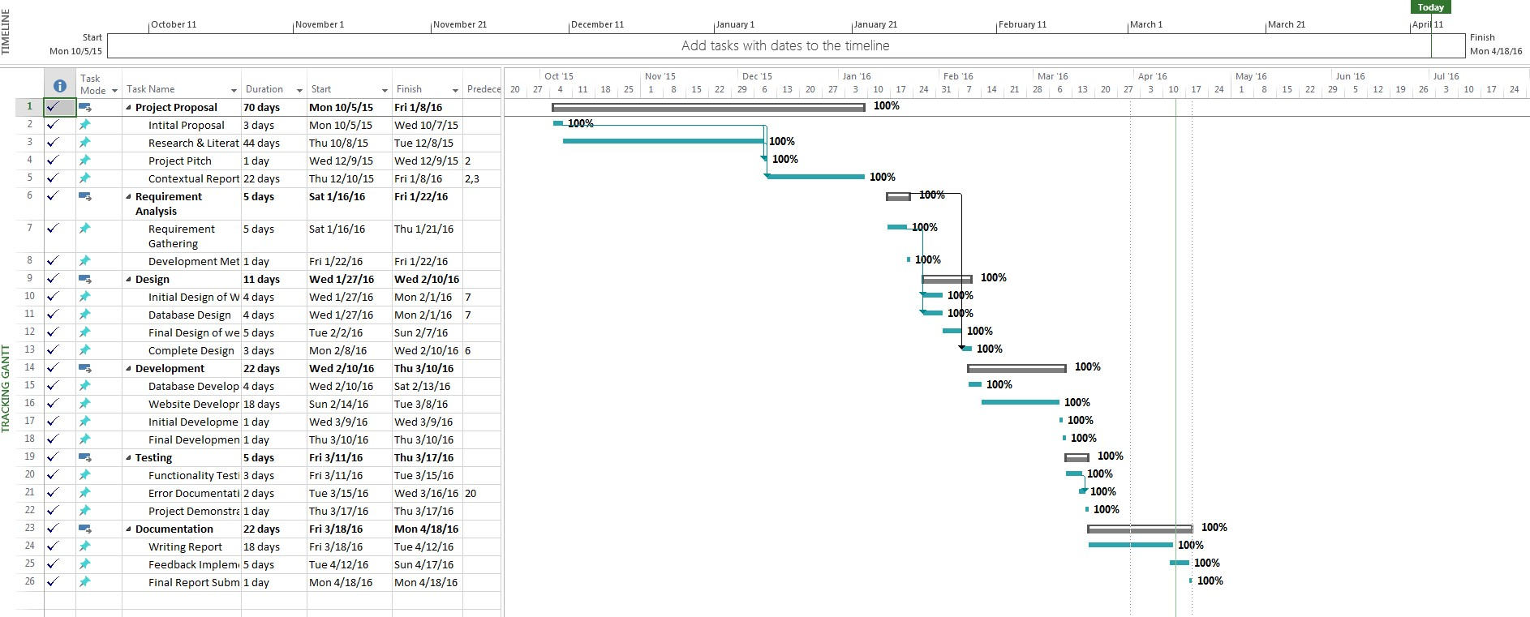

## 12.3 APPENDIX C-Existing Product Comparison Table

|  |  |  |  |
| --- | --- | --- | --- |
| **CRITERIA** | **Parcel 2go** | **Parcel monkey** | **Interparcel** |
| **Strive for consistency** | The website is consistent in term of design and layout. The menu bar appears the same on all the pages of their site. They used basic language to make it easy for the user to understand and acknowledge What their site is about. | Parcel monkey also consistent in terms of design and layout. The menu bar appears the same on all the pages of their site.  Basic language were used to make it easy for the user to understand and acknowledge what their site is about. | Interparcel has consistency in term of design and layout. The menu bar appears the same on all the pages. It has also used basic language to make it easy for the user to understand and acknowledge what their site is about. |
| **Enable frequent**  **users to use shortcuts** | The site allows the user to perform familiar action easily and quick | The Parcel monkey site allows the user to perform familiar action easily and  quick | Interparcel allow the user to perform familiar action easily and quick |
| **Offer informative feedback** | The site allows the user to get feedback once an action is performed | Parcel monkey site it does not allow the user to get feedback once they enter a wrong details on the Get Quotation. | Interparcel allows the user to get feedback once an action is performed |
| **Design dialog to yield closure** | The website does notify the user if an action is completed or indicate to the user what the next step is required to complete the task. | The website for Parcel monkey do not notify the  user if an action is completed or does not indicate to the user what is the next step required to complete the task. | The Interparcel website does notify the user if an action is completed or indicate to the user what is the next step required to complete the task. |
| **Offer simple error handling** | This site does allow the user to be informed if any error occurs when performing an action this will prevent the user from making major error. | Parcel monkey site do not allow the user to be informed or notified, if any error occurs when performing an action to prevent the user from making major error. | Interparcel site does allow the user to be informed or notified if any error occur when performing an action to prevent the user from making major error. |
| **Permit easy reversal**  **of actions** | The website does allow the user to access pages they want, if it is accessible the user can go back to the main page at any time. | The Parcel monkey website does allow the user to access pages they want, if it is accessible the user can go back to the main page at any time | Interparcel website allows the user to access pages they want, if they is accessible the user can go back to the main page at any time |
| **Support internal**  **locus of control** | The website allows the user to initiate an action and response to the action set by the user. | Parcel monkey site allows the user to initiate an action and response to the action set by the user. | The website for Interparcel allows the user to initiate an action and response to the action initialize by the user. |

|  |  |  |  |
| --- | --- | --- | --- |
| **Reduce short-term**  **memory load** | The site displays a single page at a time to allow the user to read relevant information about their concern. | The Parcel monkey site displays a single page at a time to allow the user to read relevant information about their concern. | Interparcel site displays a single page at a time to allow the user to read relevant information about their concern. |

## 12.4 APPENDIX D- Testing table

|  |  |  |  |
| --- | --- | --- | --- |
| **Usability Testing** | | | |
| **Tested Area** | **Test** | **Result** | **Comment on result** |
| **Format consistency.** | Test that fonts and Positioning of main components such as header and navigation buttons are used consistently throughout the pages of the website. | Successful | The website layout, fonts and design is consistent throughout |
| **Purpose of the website/goal of the business is clear and the desired impression of the**  **“MailSmart” website.** | Use exploratory testing with the client “You are a potential client of the  “MailSmart” business and you would like to for a quotation, by filling the required field on the page, the admin will send you an email response to the provided email address with the customise price. | Successful | The client did not take longer than necessary  Filling up the required field and to understand the purpose of the website also services offered. |
| **The navigation around website is clear.** | Can the user see and able to understand the navigation menu which appear on all the pages of the website? | Successful | It was very clear for the user to understand the intended message on the website |
| **Potential users/Registered can contact the admin or locate the business.** | Use exploratory testing with the client: “You have an issue and want to contact the admin to discuss about it or come in to discuss the issue. | Successful | It took the client less than two minute to fill out the form, and send an enquiry and it also simple finding the location of the business. |
| **Desktop**  **Application** | User to register client. | Successful | It took the potential client five minutes and few seconds to complete the |

|  |  |  |  |
| --- | --- | --- | --- |
|  | User Verification testing.  Was the potential user able to complete registration, Time taking by the user to complete the form and note any issues/comments |  | registration and activate their account. Observations: Client had trouble with password fields as validation were set to ensure that information are protected, it require the mix of numbers, lower and upper case letters |
| **Desktop**  **Application** | User can view the user account once logged in.    Use verification testing: Is the registered user able to access to their user account?  Time the user and note any issues/comments. | Successful | It took the client less than a minute to login and view their user account. |
| **Desktop**  **Application** | User can view and edit  their details    Use verification testing: Is the user able to see and edit their personal information and edit | unsuccessful | The user were not able to view or edit their personal information due to the functionality not been implemented at this stage of the project. This will be implemented before the website is up and running live. |
|  | User able to view history of their Quote.    Use verification testing: Is the user able to view history of their  Quotations? – Time the user and note any comments/issues. | Unsuccessful | The user were not able to view history of their Quotations due to the functionality not been implemented at this stage of the project. This will be implemented before the website is up and running live |
| **Application** | Is the user able to use the support center? Note any comments/issues. | Unsuccessful | The user were not able to use the support center due to the functionality not been functional at this stage of the project. This will be implemented before the website is up and running live |
| **Website** | Suitability  Professional look and feel. | Successful | Website has professional layout and language throughout. |
| **Website** | Suitability  Professional look and feel. | Successful | Website has professional layout and language throughout. |
| **Website** | Clear, logical, professional language free from errors. | Successful | Content is free from spelling and grammar errors. |
| **Website** | Does it give a commercial vibe | Successful | Advertisements are displayed on the website. |
| **Website** | Does the website display properly in: Internet Explorer  Google Chrome  Mozilla Firefox | Successful | Website displays as desired across all platform e.g. Internet Explorer, Google Chrome, and Mozilla Firefox. |

## 12.5 APPENDIX E- Testing

|  |  |  |  |
| --- | --- | --- | --- |
|  | **Accessibility Testing** | |  |
| **Tested Area** | **Conducted test** | **How to test** | **Comment and result** |
| Website | Text is clear and readable of contrasting background color | Check if the text color contrasted with the background used for the website | Black text on white background and white  text on blue background |
| Website | Check if the text size can be increased or decreased | Navigate to all pages of the website to manipulate the text size. | Functionality no implemented |
| Website | Alternative image for promotion | Check if images for promotion exist on the pages | Pages do not have promotion images. |

## 12.6 APPENDIX F- Record of Client Meetings

|  |  |  |  |  |
| --- | --- | --- | --- | --- |
|  | **Record of Client meeting** | | | |
| **Date** | **Location** | **Meeting Agenda** | **Objective** | **Duration** |
| 29/10/2015 | Client site. Croydon | Initial meeting for the project | Discuss with the client about the project. The problems solving with the current running website. | Approx. 1hr  30mins |
| 15/11/2015 | Client site. Croydon | Initial  requirement Analysis | To gather the initial requirement for the “MailSmart” website | Approx. 2hr |
| 27/11/2015 | Client site. Croydon | Second  Requirement  Meeting | To finalise and confirm the agreed requirement for the “MailSmart” business website | Approx. 3hr  20mins |
| 18/12/2015 | Client site. Croydon | Initial drawing of web pages | To demonstrate to client the design of web pages | Approx. 1hr |
| 15/01/2016 | Client site. Croydon | Final sketch design of web pages | To Finalise and confirm the final design of the web pages | Approx. 1hr |
| 15/03/2016 | Client site. Croydon | Usability testing with client | To carry out usability testing on the  “MailSmart” website | Approx. 2hr |

## 12.7 Appendix –G Coding segments explained

### 12.7.1 Home Page CSS Code

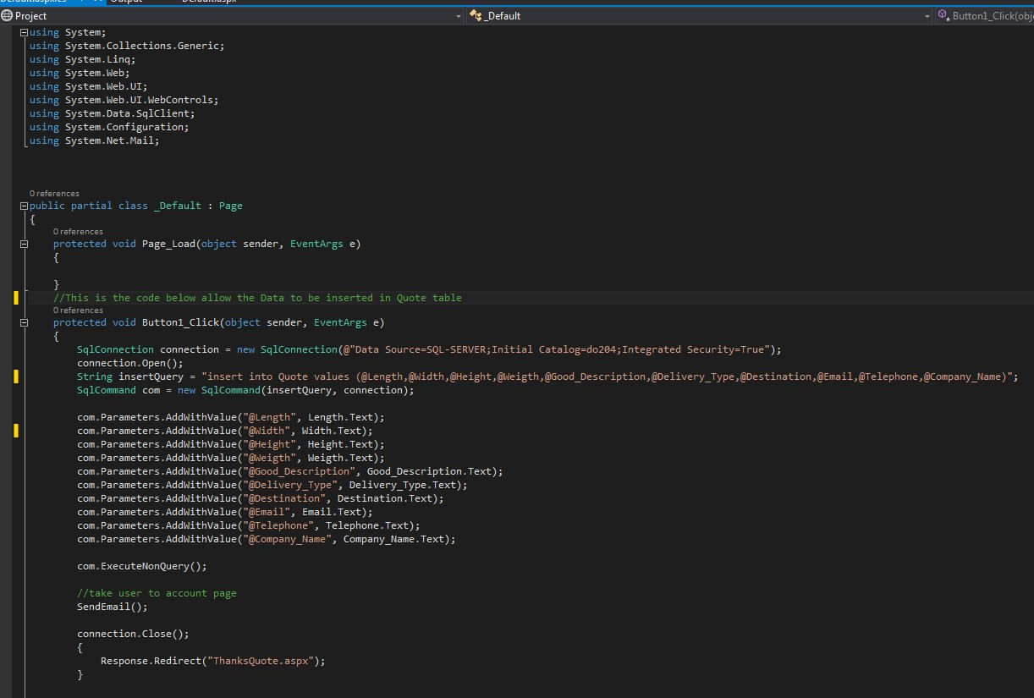

This highlighted code is

the connection string that

allow the data to inserted

into the Quote table

This highlighted code is

the connection that email

to be send

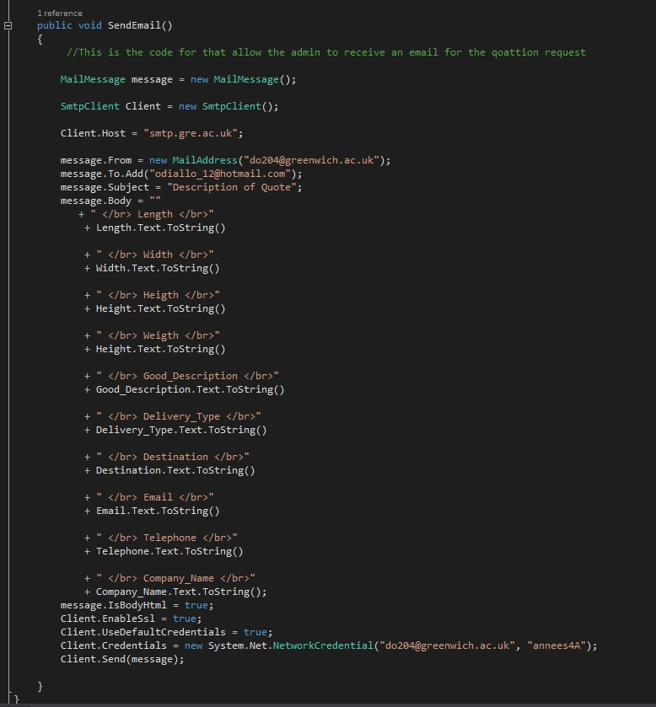

This code allow the

message to be send

to receiver



This show the

sende

r email and

the receiver which

is the admin and

subject for the

message. This

support the email

sending.



This is the code

for the field on

the home page.

This support the

adding of data to

the Quote table.

### 12.7.2 Registration Page CSS Code

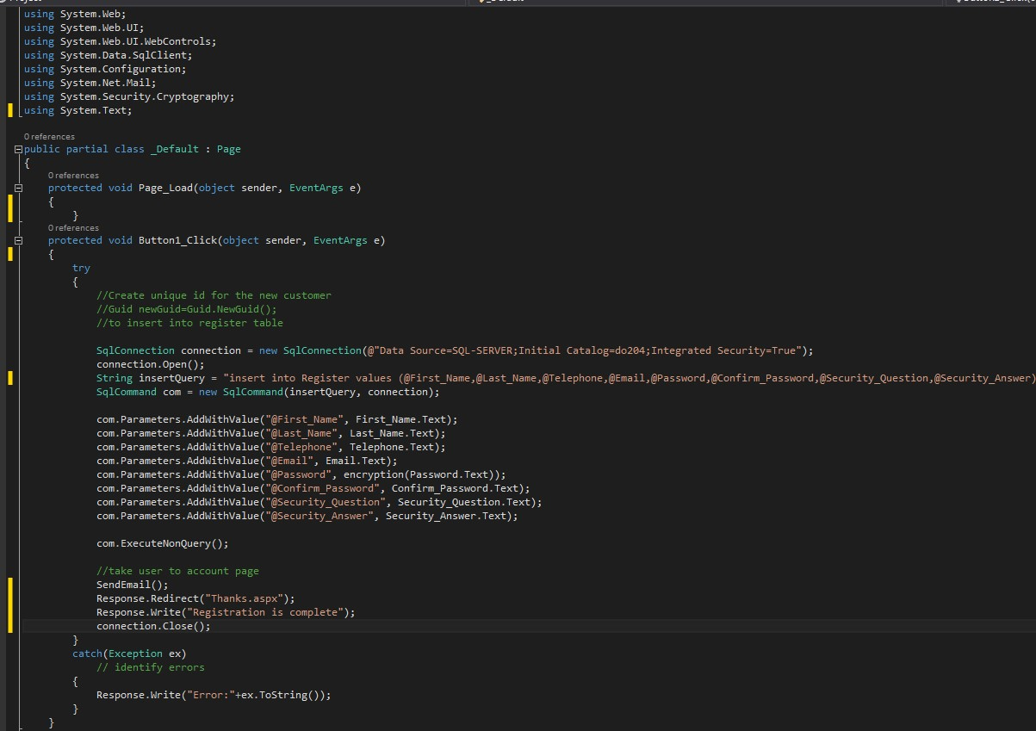

This section of the code allow the

user to be re

directed to welcome

page and a notice about completing

the registration form.

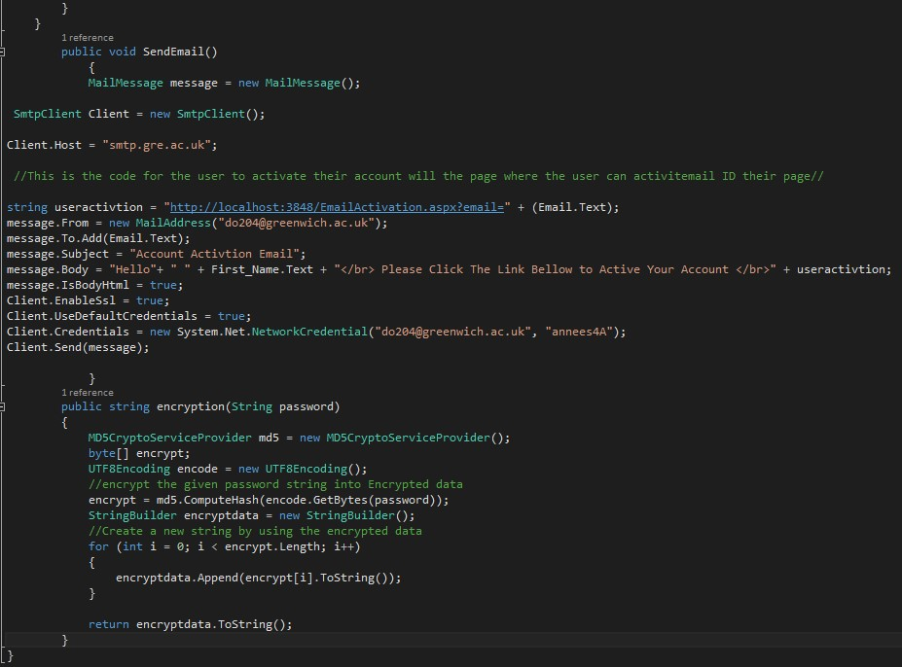

This section of the

code is the email

confirmation link

This section of the

is used to encrypt

the user password

### 12.7.3 Login Page CSS Code

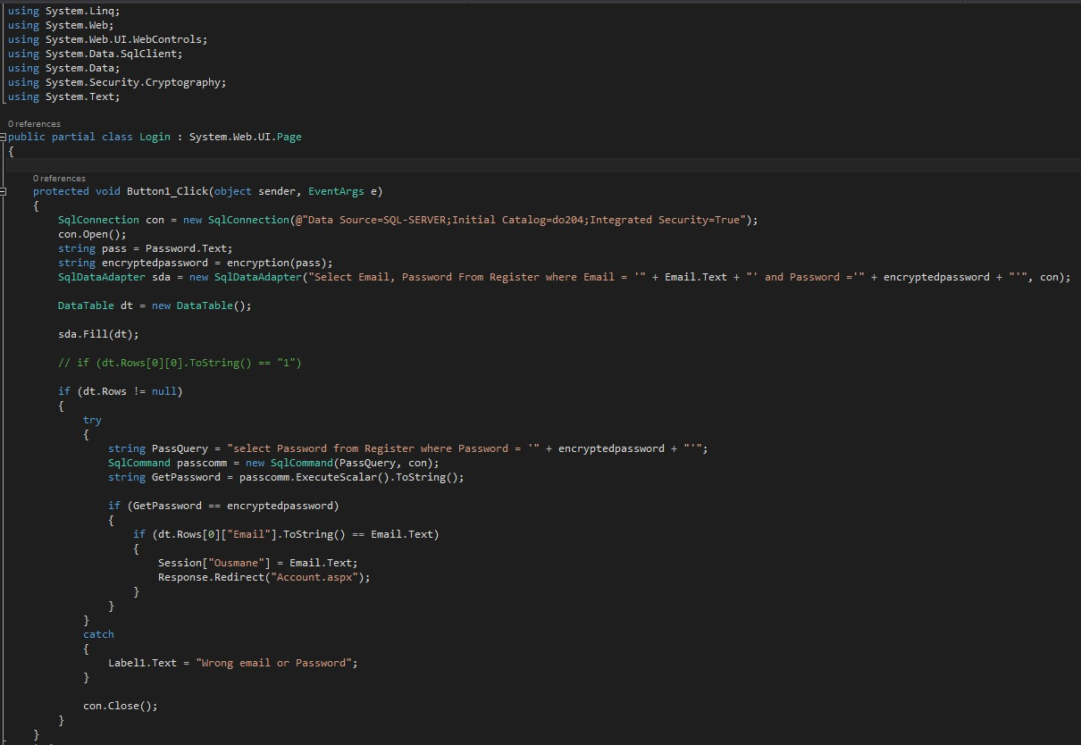

This code

assist in the

decryption

of the

password

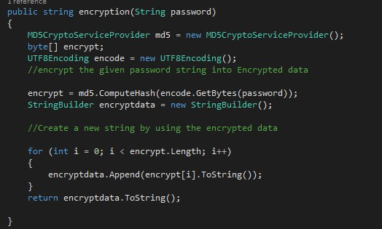This section of the decrypt the user password to allow to login using the registered password.

### 12.7.4 Contact Us Page CSS Code

|  |  |
| --- | --- |
| |  | | --- | | This section of the code allow data to be inserted once all the fields are filled and send information by email to the administration email. | |

